Spaghetti Soapbox Derby Pre/Post-Quiz

- Which of the following activities will increase the gravitational potential energy of an object?
Circle all that apply.
- Change the object’s color by painting.
- Increase the height of the object above the ground.
- Add more mass to the object.
- Push the object so it travels faster along the ground.
- In the diagram below, label the position of the pasta car that correspond to the following:
- The highest kinetic energy
- The highest potential energy
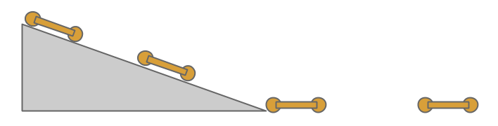

- You are tasked to design a new car for the XYZ motor company. Your manager tells you that the vehicle must weigh less than 2,000 lbs. and be shorter than 13 feet in length. The engine and the seats inside have already been designed by other engineers. Given these instructions, what is one design constraint that you must follow?

- Will any two objects traveling at the same speed have the same kinetic energy? Why or why not?

- Would changing only the rolling resistance of a vehicle change the amount of potential energy it has at the top of the ramp?

