Design and Fly a Kite Quiz
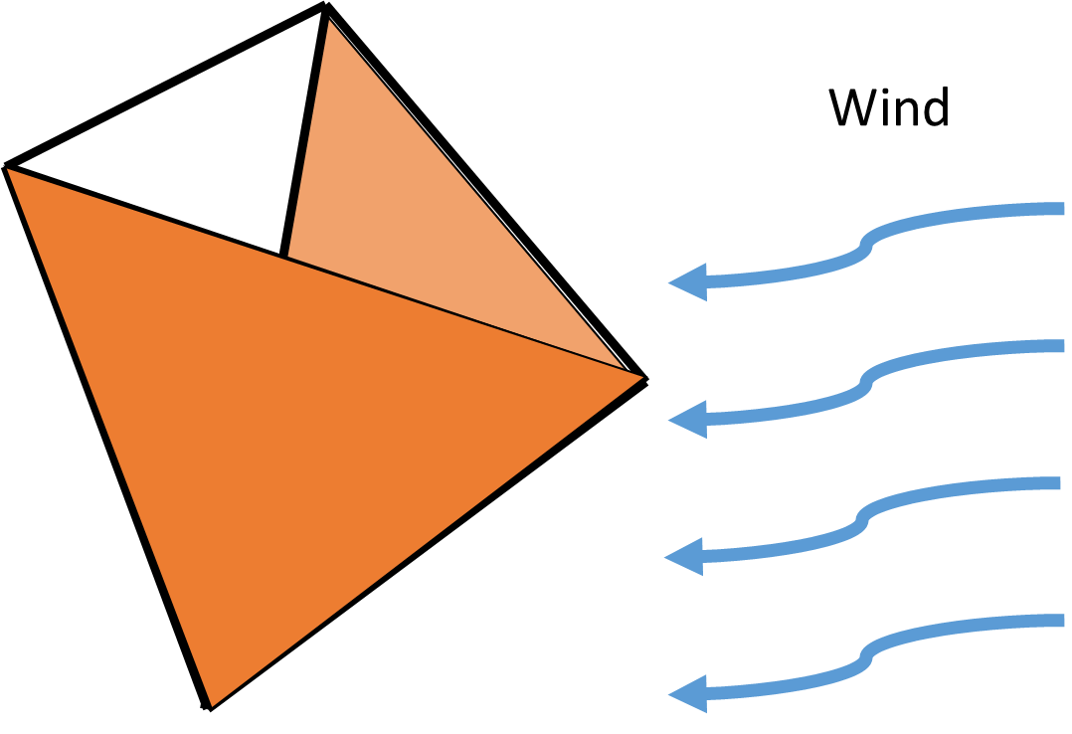
- On the diagram below, draw and label arrows showing forces acting on the kite.
Specifically, include the direction of the force and who/what is applying that force.

- Why do engineers create prototypes?
_________________________________________________________________________________
_________________________________________________________________________________
_________________________________________________________________________________
- Describe the steps of the engineering design process:
_________________________________________________________________________________
_________________________________________________________________________________
_________________________________________________________________________________
_________________________________________________________________________________
- Match the word to its definition by connecting them with lines.
- lift | The act of pushing, pulling or applying pressure.
- drag | A system (such as a kite) that consists of multiple subunits that complete the whole design.
- force | A force, opposite to gravitational force, created by fluid (air) flowing past an object.
- tetrahedron | Force that opposes the motion of an object traveling through fluid.
- modular | A three-dimensional shape made of four equilateral triangles.

