Design and Fly a Kite Pre/Post-Quiz Answer Key

- On the diagram below, draw and label arrows showing forces acting on the kite.
Specifically, include the direction of the force and who/what is applying that force.
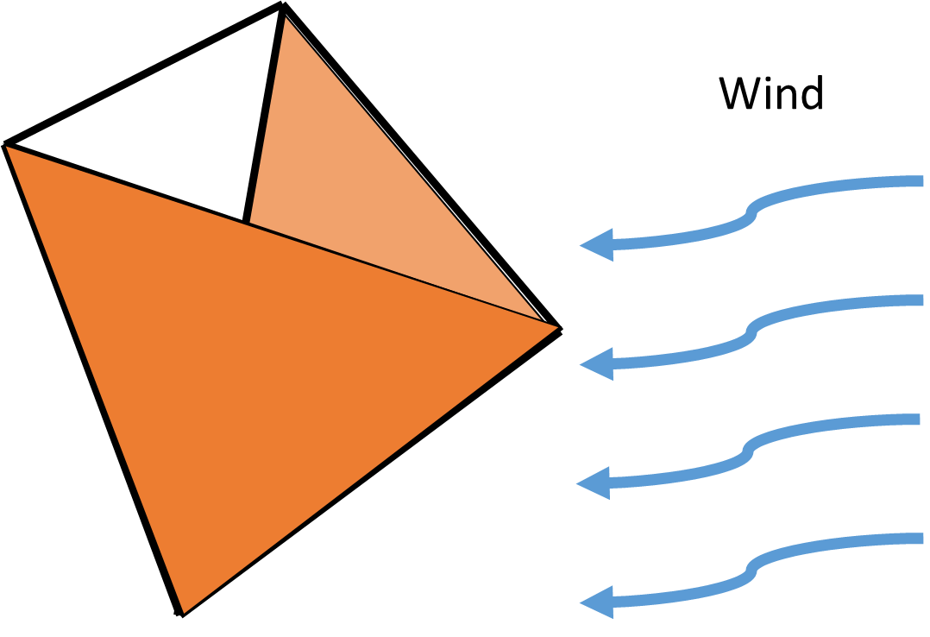
lift
gravity
wind

- Why do engineers create prototypes?

Example answer: Engineers build prototypes as a way to examine initial designs before they go into full production. Creating and testing prototypes brings up unexpected issues and problems to correct so the initial design can be improved and refined.

- Describe the steps of the engineering design process: Example answer: The engineering process begins with 1) the identification of what is needed and the constraints (requirements and limitations) to meet those needs. 2) Engineers research the problem to fully understand it. Engineers then 3) think of many possible solutions and 4) select the most promising one to prototype. They 5) build a prototype and 6) test/evaluate it to analyze how closely the design meets the needs and constraints. 7) Then engineers redesign as often as necessary to improve the design until it is considered an acceptable solution.

- Match the word to its definition by connecting them with lines.
- lift | The act of pushing, pulling or applying pressure.
- drag | A system (such as a kite) that consists of multiple subunits that complete the whole design.
- force | A force, opposite to gravitational force, created by fluid (air) flowing past an object.
- tetrahedron | Force that opposes the motion of an object traveling through fluid.
- modular | A three-dimensional shape made of four equilateral triangles.

