Engineering Design with Application to Unpowered Flight Worksheet
Answer Key
- Create a checklist of needs and constraints, which are the project’s requirements and limitations:
- Needs to be able to fly in the wind.
- Each tetrahedron must use six plastic drinking straws.
- Tetrahedrons may only be connected at the corners.
- Each tetrahedron must be covered on two sides.
- In the spaces below, draw different tetrahedron kite designs. If more space is needed, use the back of this sheet, or a blank piece of paper stapled to this sheet. Draw arrows to show the forces from wind and gravity.
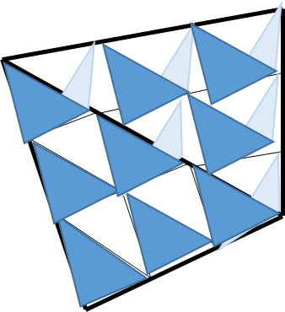 | 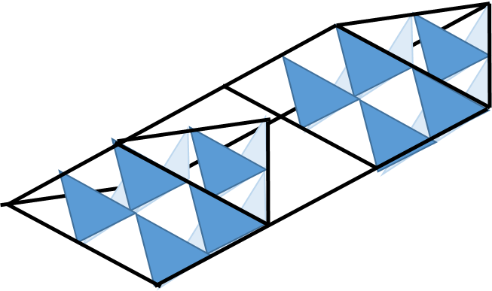  examples
- In the spaces below, draw your redesigned tetrahedron kite design and describe how and why you changed the initial design.
re-design  example  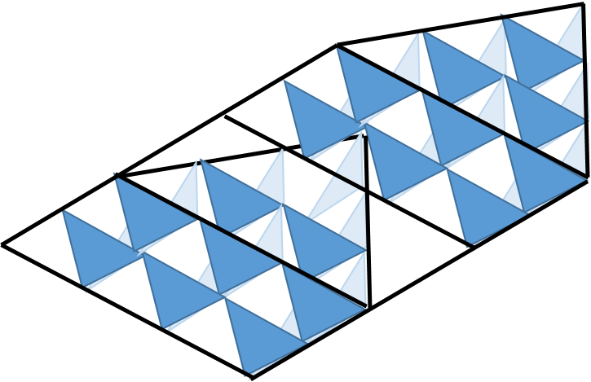 | List of changes made and reasons why:
 | The second kite (above) was our initial design and
 | it flew really well. We expect that adding another
 | row of tetrahedrons will still allow it to fly while
 | also increasing the number of tetrahedrons used.

