Sliding Textbooks Experimental Setup Visual Aid
The diagrams below show the experimental setup for the class activity and the pulley extension version.
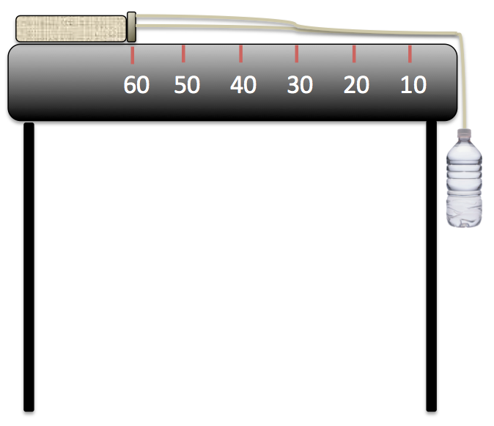
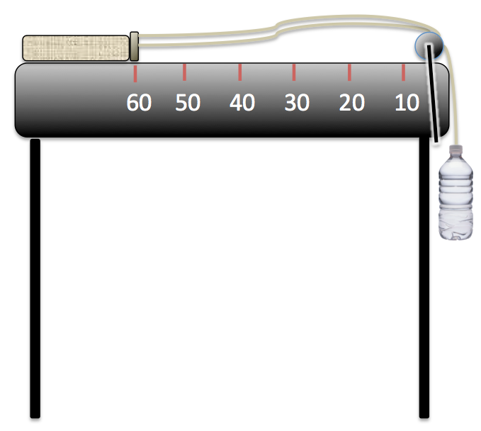

Setup without pulley.
Setup with pulley.
(activity extension)

