Sliding Textbooks Worksheet
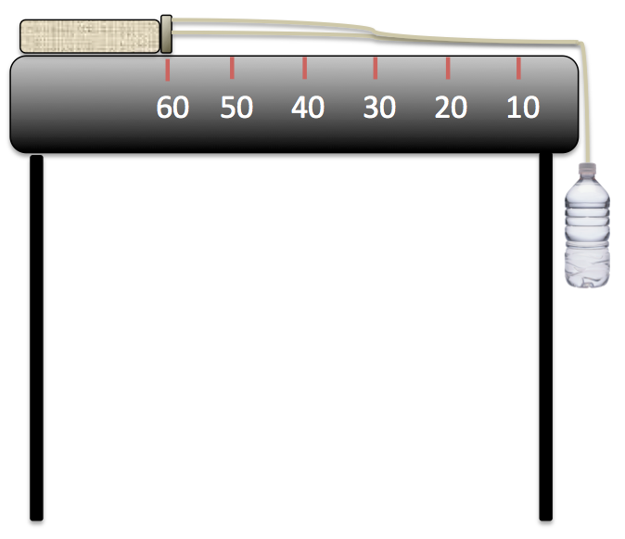
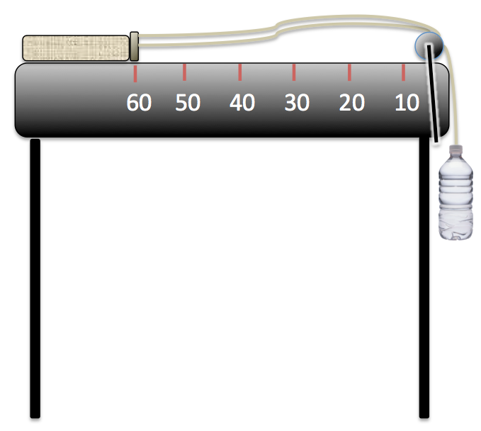
Sliding Textbooks: An Experiment Exploring the Nature
of Forces, Friction and Acceleration Due to Gravity

Setup without pulley. Setup with pulley.

Materials List (for each group)
- table or desk
- string, a bit more than 2 meters
- measuring tape, at least 1 meter long
- stopwatch
- textbook weighing 0.5-0.75 kg
- ~60 cm (~24 in) length of one material; choose from wax paper, plastic wrap, baking parchment paper, aluminum foil (or any other material provided by the teacher)
- tape
- plastic soda bottle, 12 oz size (≈ 355 ml), with a small hole pierced in the bottle cap
- water and graduated cylinder
- graph paper
- (optional) pulley with table clamps
Experiment Setup & Overall Procedures
- Measure 60 cm from the table edge, and place the spine of the textbook at the 60 cm mark.
- Loop the string around the spine of the textbook.
- Tie the two ends of the string together just above the bottle cap.
- Pierce a small hole in the middle of the bottle cap, just large enough to thread the string through.
- Thread the string through the top of the bottle cap, and tie a knot to secure it.
- In each of the following replications of the experiment, fill the bottle with the indicated volume of water. Then screw the cap onto the water bottle, holding the bottle (do not let the bottle hang yet). Start the stopwatch at the moment the water bottle is released. Stop the watch when the spine of the textbook reaches the 10 cm mark. Record the time on the worksheet, along with observations.
- Time each run (at every volume of water) three times.
Observations & Measurements
Experiment 1
Fill the bottle with 125 ml of water. Observe what happens. Does the book slide? Why or why not?
____________________________________________________________________________________
A. If the book slides, repeat the experiment three times, and record the time to go from 60 cm to 10 cm:
Trial 1: ______ Trial 2: ______ Trial 3: ______

Now fill the bottle with 150 ml of water. Does the book slide? Why or why not?
____________________________________________________________________________________
B. If the book slides, repeat the experiment three times, and record the time to go from 60 cm to 10 cm:
Trial 1: ______ Trial 2: ______ Trial 3: ______

Now fill the bottle with 175 ml of water. Does the book slide? Why or why not?
____________________________________________________________________________________
C. If the book slides, repeat the experiment three times, and record the time to go from 60 cm to 10 cm:
Trial 1: ______ Trial 2: ______ Trial 3: ______

Now fill the bottle with 200 ml of water. Does the book slide? Why or why not?
____________________________________________________________________________________
D. If the book slides, repeat the experiment three times, and record the time to go from 60 cm to 10 cm:
Trial 1: ______ Trial 2: ______ Trial 3: ______
Experiment 2
In this experiment, you explore the effect of different surfaces on the amount of friction exerted on the book. Your engineering challenge is to determine which material will make the best “runway” so your book accelerates the fastest.
Choose from wax paper, plastic wrap, baking parchment paper, aluminum foil.
Prediction: How do you think the runway made from the material you chose will affect the acceleration of the textbook?

Tape the material to the tabletop.
Follow the Experiment 1 procedures, recording your time measurements and observations, but this time with the new surface in place.

Fill the bottle with 125 ml of water. Observe what happens. Does the book slide? Why or why not?
____________________________________________________________________________________
A. If the book slides, repeat the experiment three times, and record the time to go from 60 cm to 10 cm:
Trial 1: ______ Trial 2: ______ Trial 3: ______

Now fill the bottle with 150 ml of water. Does the book slide? Why or why not?
____________________________________________________________________________________
B. If the book slides, repeat the experiment three times, and record the time to go from 60 cm to 10 cm:
Trial 1: ______ Trial 2: ______ Trial 3: ______

Now fill the bottle with 175 ml of water. Does the book slide? Why or why not?
____________________________________________________________________________________
C. If the book slides, repeat the experiment three times, and record the time to go from 60 cm to 10 cm:
Trial 1: ______ Trial 2: ______ Trial 3: ______

Now fill the bottle with 200 ml of water. Does the book slide? Why or why not?
____________________________________________________________________________________
D. If the book slides, repeat the experiment three times, and record the time to go from 60 cm to 10 cm:
Trial 1: ______ Trial 2: ______ Trial 3: ______
Calculations
How far did the textbook travel going from the 60 cm mark to the 10 cm mark? _________________
Call this distance “d.”
Average the times for each trial (A, B, C, D in Experiment 1, and E, F, G and H in Experiment 2). Record the average times in the table below.
Next, use these average times, together with the distance traveled, to calculate the average acceleration using the equation: a = 2d/t², where d is distance and t is time.
 | Avg Time (t) | Avg Acceleration (a) |  |  | Avg Time (t) | Avg Acceleration (a)
A |  |  |  | E
B |  |  |  | F
C |  |  |  | G
D |  |  |  | H
Results
Weigh the empty water bottle. Knowing that 1 ml of water ≈ 1 gram (at 4 °Celsius, the equation is exact), calculate the mass of the bottle filled with water at each volume of water.
125 ml plus bottle = __________ kg 175 ml plus bottle = __________ kg
150 ml plus bottle = __________ kg 200 ml plus bottle = __________ kg
Analysis Questions
- When you put more mass (water) into the soda bottle, what happens to the average acceleration (does it get faster or slower)? Why?

- On graph paper, plot the points from the first experiment (without the runway) and connect them as a line. Do the points lie perfectly in a line? Why or why not?

- What difference do you see between Experiment 1 (the table and book) and Experiment 2 (with the “runway”)? Did the textbook accelerate faster or slower with the new material (wax paper, plastic wrap, baking parchment paper or aluminum foil) for the runway surface? Why?

- For what types of situations might you want a smooth material?

- For what types of situations might you want a rough material?

