Soil Biosolarization Activity Handout
ENGINEERING TEAM NAME:
Member names:

Roles: Each member of the engineering team is an agricultural engineer. While all team members are responsible to participate in all components of the experimental activity, each team member is also responsible for a specific task. Designate your individual team member tasks:
READER:
WRITER:
SPEAKER:
ORGANIZER:
Session 1: Experiment Setup
- Measure the volume of the seed starter pots using the graduated container:
- Use the graduated container to fill the pot with soil and record the volume of the pot.
- Calculate 95% of the volume of the pot. 95% of the pot’s volume will be soil.
- Calculate 5% of the volume of the pot. 5% of the pot’s volume will be “organic waste.”
Make sure you use the correct units.
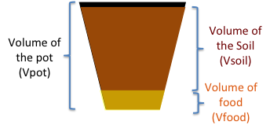 | Name | Value | Unit | Equation
 | Pot Volume (V_{pot})
 | 95% Volume (V_{soil}) |  |  | $$Vsoil=\frac{Vpot×95}{100}$$
 | 5% Volume (V_{food}) |  |  | $$Vfood=\frac{Vpot×5}{100}$$
- Fill three pots with only soil.
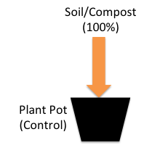

These are the control samples.
Control samples help scientists and engineers identify the normal (unchanged) conditions.

- Fill the other three pots with 95% soil and 5% organic waste (such as oatmeal).
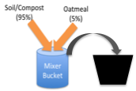
This is our experiment. We are testing the effect of adding organic waste.

- Once the pots are ready, plant 10 seeds in each pot. Record the number of seeds in Table 1, on the last page of this handout.
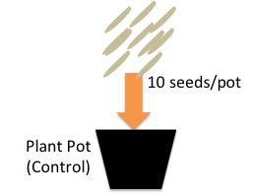

The seeds represent the weeds that farmers want to eliminate so they can grow lots of fruits and vegetables.

- Place a container or tray under the six pots. Water the pots until water comes out of the bottom. Then cover the pots with plastic wrap.
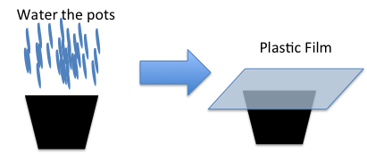

The thirsty microorganisms will use the water as they eat the food.

- Move the pots to a sunny indoor spot and leave them for solarization for at least 1 day (no more than 1 week is recommended).
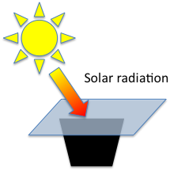

The plastic film creates the greenhouse effect inside the pot. Solar radiation can travel through the plastic wrap, but cannot leave, so the pot warms up. Also, when microorganisms eat the food, they produce gases that also stay in the pot because of the plastic wrap.

Session 2: Data Collection (1 day after Session 1)
- Remove the plastic wrap from all the pots.
- Smell every pot and record your observations in Table 1.
- Measure and record in Table 1 the temperature of each pot.
Expect the accumulated gases to have a strong smell because the microorganisms have been eating and making new chemicals that get trapped by the plastic wrap. Expect the temperature inside the pot to be much higher than the air temperature. Both the gases and the high temperature inactivate (kill) the weed seeds.

Session 3: Data Collection and Analysis (1 week after Session 2)
- Count the number of seedlings in every pot and record the counts in Table 1.
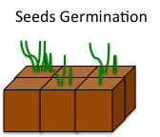
Seeds that survived the high temperatures and gas concentration will grow. By counting them and comparing with the number of weeds that grew in the control pots, we can determine if the experiment worked or not.

- Calculate the weed seed inactivation using the following equation:
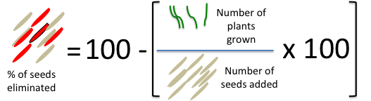

- Which of the experiments eliminated the most weeds?
Explain your answer using results from the experiment.

Table 1. Experiment measurements, observations and calculations.
 | Session 1 |  |  |  | Session 2 |  | Session 3
Treatment | ID | Volume soil (ml) | Volume waste (ml) | # seeds | Temp. (°C) | Does it smell?  Describe the smell. | # plants | % seeds inactivated
Control-1
Control-2
Control-3
Mean Control
Treatment-1
Treatment-2
Treatment-3
Mean treatment
Additional notes:

