Post-Activity Quiz Answer Key
- Is a plastic bottle organic waste? Check yes or no: Yes No
Why?
Plastic is not organic waste because it cannot be broken down by microorganisms and other living things into carbon dioxide, water, methane or simple organic molecules.

- Is compost considered organic waste OR a product that we can use to grow plants?
Compost is a product that we can use to grow plants. While its origin is as an organic waste, it is no longer waste because it has a specific use.

- What is a pesticide?
A pesticide is a chemical preparation used for destroying/eliminating plant, fungal or animal pests.

- Why do many farmers wear masks when they are applying pesticides?
Farmers wear masks when applying pesticides because pesticides are toxic chemicals.

- Explain the greenhouse effect.
The greenhouse effect is a phenomenon in which the sun's radiant heat passes through glass or plastic, is trapped, and warms the area covered by the glass or plastic; the heat inside is prevented from escaping by the glass or plastic.

- Two farmers needed to get rid of the undesired plants (weeds) in the soil in two different plots where they intend to plant tomatoes. The first farmer had 90 weeds on his plot. He treated the plot using soil biosolarization. After 10 days, 8 weeds were alive. The other farmer applied a pesticide eliminating 60% of the weeds.
- Estimate the percentage of weeds that was eliminated by soil biosolarization.
Soil biosolarization removed (90-8)/90*100=91% of weeds.

- Which weed-eliminating method was more effective?
Treating the soil with biosolarization was more effective because it removed a considerably higher percentage of weeds. In addition, the soil biosolarization technique reduced potential negative effects on the farmers and the environment from the use of pesticides.

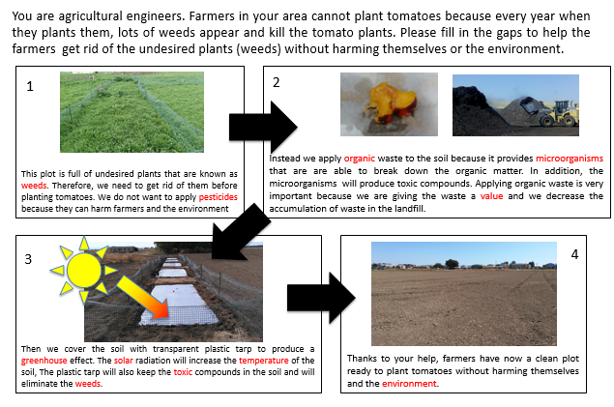
7.

