Tower to the Moon Main Activity (Gr3-5) Answer Key
Your design challenge: Following the steps of the engineering design process, build the tallest straw tower possible using no more than 50 plastic drinking straws and 1 meter of tape?
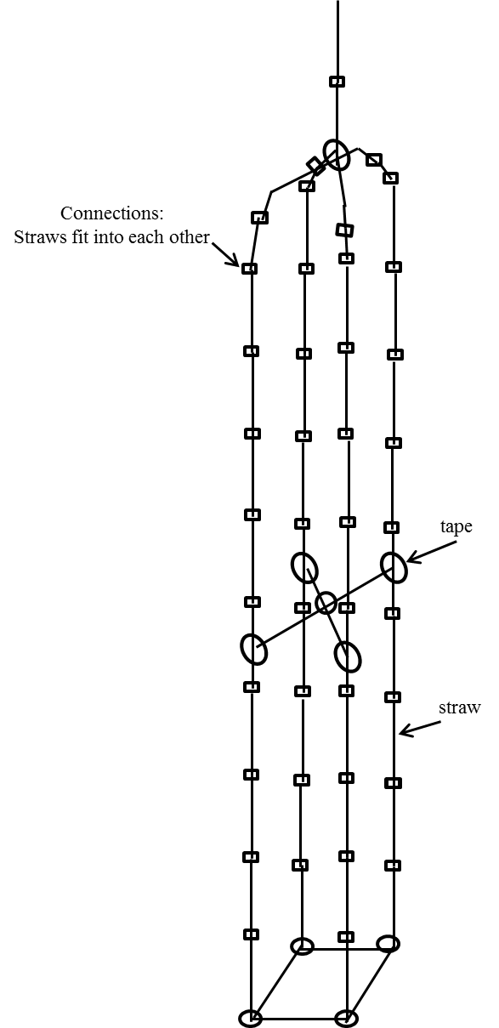
- Ask: We need to design and build the tallest straw tower and we are restricted to 50 straws, 30 minutes of time, and 1 meter of tape.
- Research the problem: We researched when comparing and contrasting features between taller and shorter towers and discussing how we can make a structure taller.
- Imagine: Draw and label how you would build the tallest straw tower with 50 disposable drinking straws and one meter of tape. Label the materials used.
50
For this design, how many straws do you need? ______________
Example answers

- Plan: Are you selecting your or your partner’s solution (or some combination)? Explain.
Example answer: We decided to select my plan to build.
- Create: Build your tower.

- Test and evaluate: Measure and record: For each groups’ straw tower measure and record its vertical height and number of unused straws.
Group | Height (inches) | # of unused straws
1 | 6 | 8
2 | 9 | 0
3 | 47 | 14
4 | 0 | 2
5 | 30 | 20
6 | 31 | 18
7 | 3 | 7
8 | 41 | 24
9 | 0 | 17
10 | 16 | 31
11 | 14 | 29
12 | 10 | 35
13 | 28 | 19
14 | 25 | 13
15 | 21 | 23

Example answers

- Improve: After seeing what your classmates have created, draw a new and improved design. Label the materials used.
50
For this design, how many additional straws do you need? ________
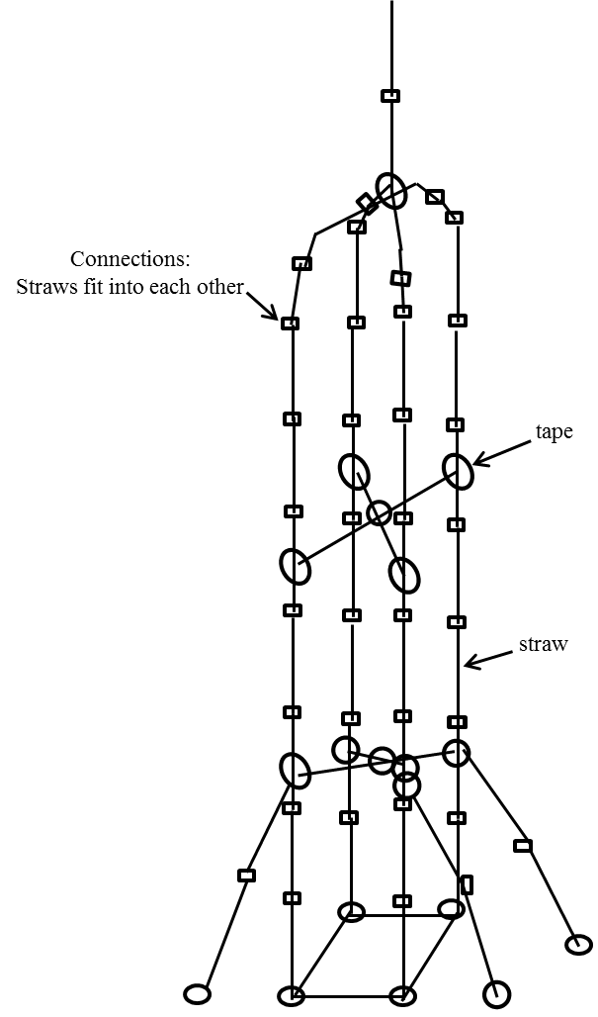
Example answers

- Build it

