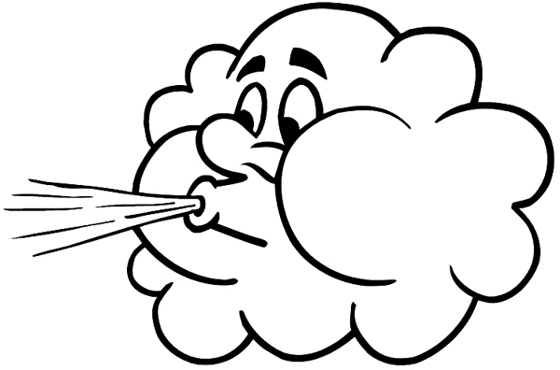
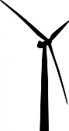
Wind Turbine Design Post-Test

- How are a wind turbine and a fan similar or different?
- They are the same. They both turn wind into energy.
- They are the same. They both turn energy into wind.
- They are opposites. A wind turbine converts kinetic energy into electrical energy, and a fan converts electrical energy into kinetic energy.
- They are opposites. A wind turbine converts electrical energy into kinetic energy, and a fan converts kinetic energy into electrical energy.
- Which of the following increases the power generated by a wind turbine?
Circle all answers that apply.
- Increasing wind speed
- Decreasing air density
- Decreasing sunlight
- Increasing blade size
- Increasing rainfall
- What happens to the power produced by a wind turbine if the blades are placed at each of the three angles below? Explain.
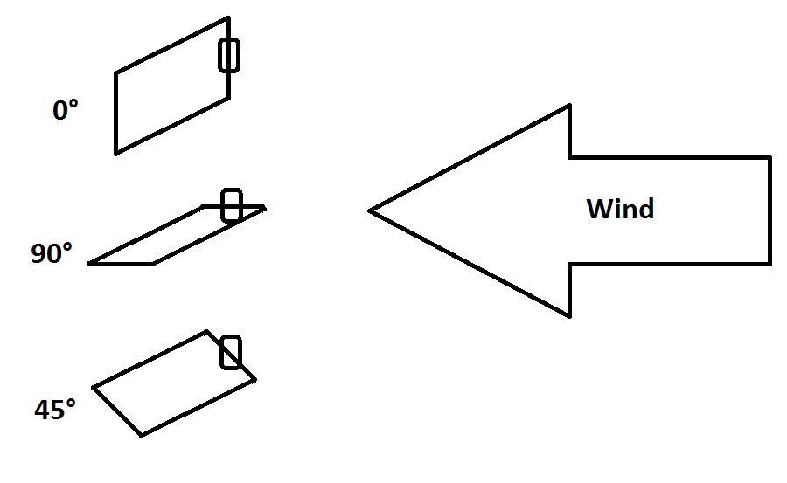
0°:

90°:

45°:

- How would you design a wind turbine to collect the most energy?
Draw an example and explain below.

