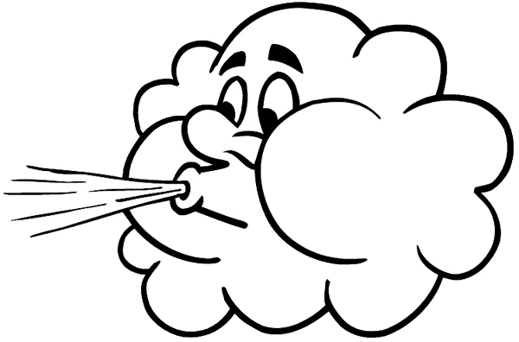
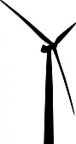
Wind Turbine Design Post-Test Answer Key

- How are a wind turbine and a fan similar or different?
- They are the same. They both turn wind into energy.
- They are the same. They both turn energy into wind.
- They are opposites. A wind turbine converts kinetic energy into electrical energy, and a fan converts electrical energy into kinetic energy.
- They are opposites. A wind turbine converts electrical energy into kinetic energy, and a fan converts kinetic energy into electrical energy.
- Which of the following increases the power generated by a wind turbine?
Circle all answers that apply.
- Increasing wind speed
- Decreasing air density
- Decreasing sunlight
- Increasing blade size
- Increasing rainfall
- What happens to the power produced by a wind turbine if the blades are placed at each of the three angles below? Explain.
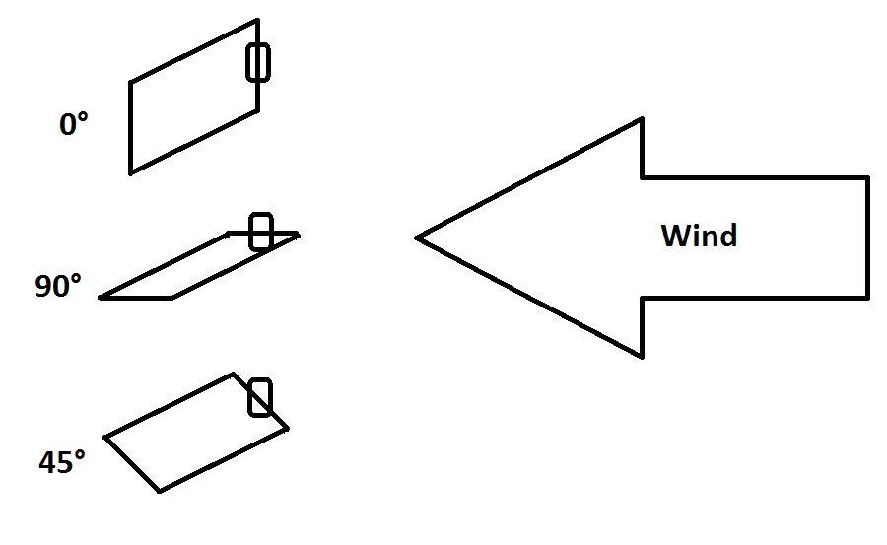
0°: At 0°, the wind will push directly into all of the blades and they will not be able to spin. Thus, the power output will be zero.

90°: At 90°, the wind will slide right over and under the blades, not transferring any of its kinetic energy. Thus, the power output will be zero.

45°: At 45°, the wind will push into the blades and slide upwards, causing the blades to spin counter-clockwise. This will cause the turbine to generate electricity and produce some amount of power.

- How would you design a wind turbine to collect the most energy?
Draw an example and explain below.
Expect student drawings to be reflect what was observed and discussed in class as the best prototype design(s) based on the evaluated results.
Expect student explanations to reflect evidence-based reasoning for why the drawn design performed best, for example, “the chosen design collected and produced the most energy (in x amount of watts) because it had the largest blades, the most blades, or was placed at the optimum angle.”

