Math Competition Test—5th Grade
- Add 7 3/4 and 3 6/7:
A. 11 4/7 B. 10 4/7 C. 11 17/28 D. 10 21/28
- Write 25% in reduced fraction form.
A. 25/100 B. 12/50 C. 5/20 D. 1/4
- Rewrite 6/16 as a percentage.
A. 6.16% B. 0.375% C. 3.75% D. 37.5%
- While on a road trip with your parents, you decide to keep track of the speed of the car. For 2 hours and 30 minutes, the car is travelling at 55 mph, for 2 hours it is travelling at 65 mph, and for 1 hour and 15 minutes you are traveling at 60 mph. What percentage of the trip is the car travelling at or above 60 mph? (Round to the nearest tenth of a percent.)
A. 57.8% B. 34.8% C. 35.7% D. 56.5%
- Write forty-seven thousandths in standard form.
A. 0.0047 B. 0.0470 C. 0.4700 D. 47
- If Greg saves 15% of his paycheck each week, and his weekly paycheck is $750, how much will he have saved in 12 weeks?
A. $112.50 B. $135.00 C. $1350.00 D. $1125.00
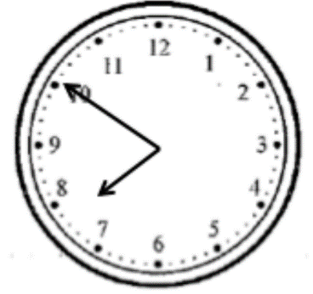
- What time is shown on the clock to the right?
A. 8:50
B. 7:10
C. 8:10
D. 7:50
- Evaluate 3 1/3 – 2 ¾ =
A. 1 7/12 B. 7/12 C. 1 2/3 D. 2/3
- What is 0.8 written as a fraction reduced to lowest form?
A. 1/8 B. 8/10 C. 80/100 D. 4/5
- Katie wants to buy a new backpack for school so she begins saving. She puts aside $5 the first week and $3 the next. She is able to keep up this pattern where one week she saves $5 and $3 the next. How long will it take to save up for a $35 backpack?
A. 8 weeks B. 9 weeks C. 10 weeks D. 7 weeks

- What digit is in the ten thousands’ place in 193,268,074?
A. 7 B. 6 C. 2 D. 1
- Every year, James measured the height of a tree in his backyard. When he was eight-years-old, the tree was 14 feet tall. When he was nine-years-old, the tree was 18 feet tall. When he was 10-years-old, the tree was 22 feet tall. If the pattern continues, how old will James be when the tree is 34 feet tall?
A. 12 B. 13 C. 14 D. 15
- Write 12% in reduced fraction form.
A. 12/100 B. 6/50 C. 3/25 D. 3/20
- On the first day of harvest, Carl goes to his orchard and picks three boxes of apples, on the second day he picks 5 boxes, and on the third 7 boxes. If he continues to get better at picking at the same rate, how many boxes will he pick on the seventh day?
A. 15 B. 13 C. 11 D. 9
- At full price, the latest gadget will cost you one-third of your savings. Luckily, you are able to buy it on sale for 4/5 of the full price. What fraction of your savings did you spend?
A. 6/15 B. 4/15 C. 5/12 D. 5/8
- What is 60% of 350?
A. 200 B. 210 C. 160 D. 175
- Compute the prime factorization of 210.
A. 6 x 5 x 7 B. 21 x 10 C. 2 x 3 x 5 x 7 D. 3 x 3 x 5 x 7
- Which of the following is NOT true?
A. −0.2 ≥ −0.3 B. −1.2 ≤ −2.3 C. 5/2 ≥ 25/10 D. 4/3 ≥1 1/2
- What is 7020.698 rounded to the nearest 10?
A. 7020 B. 7021 C. 7020.7 D. 7000
- Evaluate 5 1/3 × 2 2/7 =
A. 12 4/21 B. 10 2/21 C. 10 4/21 D. 12 2/21
- Linda wants to buy a skateboard that costs $138.00, but she has saved only one-quarter of that cost. How much more money does Linda need to save before she has enough to buy the skateboard?
A. $34.50 B. $69.00 C. $103.50 D. $98.50

- 2.647 =
A. twenty-six and forty-seven hundredths
B. six and two hundred forty-seven thousandths
C. two and six hundred seventy-four thousandths
D. two and six hundred forty-seven thousandths
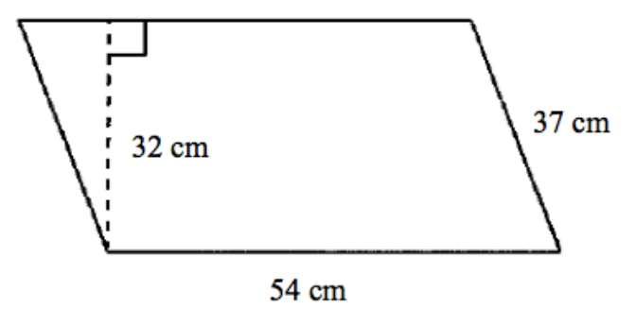
- What is the area of the parallelogram?
(Not drawn to scale)
A. 1998 cm²
B. 1184 cm²
C. 1728 cm²
D. 864 cm²
- How many feet are in 340 inches?
A. 27 1/4 B. 28 1/4 C. 27 1/3 D. 28 ⅓
- How many inches are in 9.5 feet?
A. 114 inches B. 108 inches C. 95 inches D. 113 inches
- Which of the following is TRUE?
A. 1/4 > 1/3 B. 2/4 < 1/3 C. 5/2 =25/10 D. 5/4 ≥ 25/15
- What digit is in the one-hundred thousands place in 954,230,489?
A. 4 B. 2 C. 3 D. 9
- What is the nearest integer to 1.55?
A. 1.5 B. 1 C. 2 D. 15
- Round 67.3293 to the hundredths place.
A. 67.30 B. 67.329 C. 67.32 D. 67.33
- Write seventeen thousand, six hundred forty-two in standard form.
A. 170,462 B. 17,642 C. 1,742 D. 1,642
- Write 6 5/12 as an improper fraction.
A. 65/12 B. 30/12 C. 72/12 D. 77/12
- Multiply 10.01 × 23.456 and round to the thousandths place.
A. 234.790 B. 234.795 C. 23.479 D. 234.800

