Newton's First and Second Laws Homework
Concepts: Forces Acting on Masses and Newton’s First and Second Laws
- Write a paragraph of at least 25 words using Newton’s first law to help you explain why a seatbelt can help save your life if you get into a car accident.

- Draw an arrow (vector) to show the direction of the velocity of the object in motion in the following images. The first example has been done for you.
Example:
A satellite orbiting Earth.

A biker going down a mountain. A soccer player kicking a soccer ball.
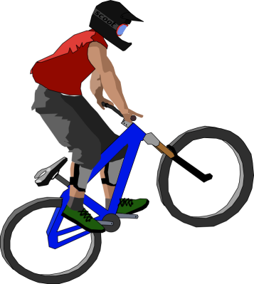
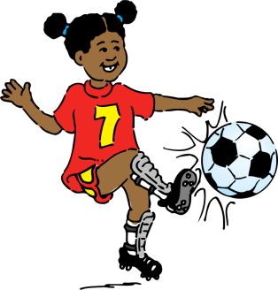

- A boy lets go of a feather. The feather is acted upon directly downward by the force of gravity with 5 Newtons and by the force of air resistance in the opposite direction (upwards) with 2 Newtons. The net force on the feather is ____.

- 3 Newtons upward
- 8 Newtons downward
- 3 Newtons downward
- 8 Newtons upward
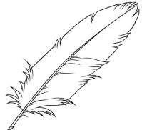
2 Newtons
5 Newtons

- A satellite in deep space is on a mission to Neptune. It fires its engines to change its velocity toward Neptune at a speed of 200 kilometers per hour. Suddenly, the engines stop working. After a few minutes, what is the velocity of the satellite?
- 100 kilometers per hour, towards Neptune
- 200 kilometers per hour, towards Earth
- 100 kilometers per hour, towards Earth
- 200 kilometers per hour, towards Neptune

