Newton's Laws Final Quiz Answer Key
- For each object in the images below:
A) Draw a solid arrow to show the direction of the velocity.
B) Answer the question: Is a force acting upon the object? (all YES)
C) Answer the question: Is the object accelerating?
D) If accelerating, draw a dotted arrow to indicate the direction of the acceleration (change in velocity).
The first one has been done for you as an example.
Tip: Remember that “acceleration” just means a change in velocity, so if an object moves in a new direction, speeds up or slows down, these are examples of a change in velocity, or “acceleration”!

Example:

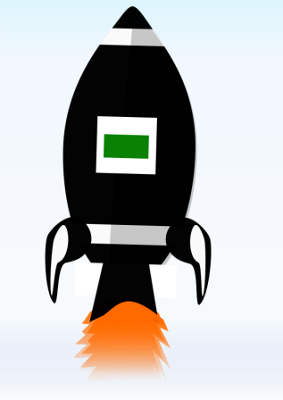

A rocket is launched.
Is it accelerating? YES

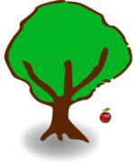

An apple falls from a tree.
Is it accelerating? _YES__
The apple accelerates downward due to the force of gravity.

Either answer is acceptable for whether the bird is accelerating.
Almost inevitably, unbalances forces (such as drag, wind) are acting on the bird. But the way the question is phrased, it is also acceptable to interpret there being no unbalanced forces, and so no net acceleration.
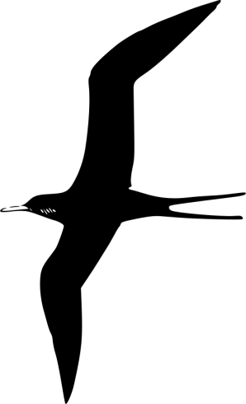

A bird soars in a straight line through the air, without flapping its wings.
Is it accelerating? _YES / NO_(see note above )

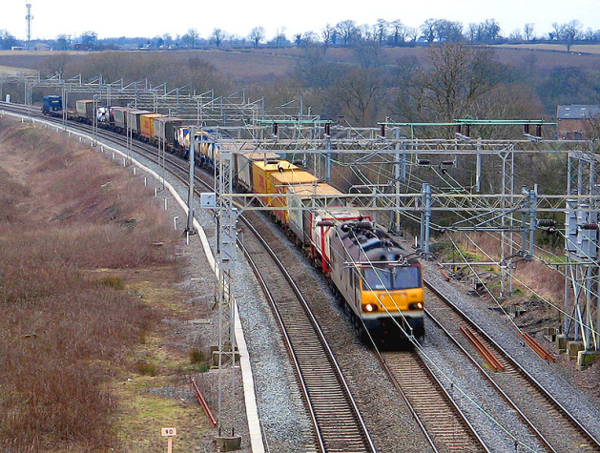

A train slows down as it pulls into a station.
Is it accelerating? _YES_
Expect students to recognize that deceleration is a form of “acceleration” in the physics definition of the word, that is, a change in velocity.
.
- When we measure the ______________________ of an object, we measure the mass of an object by using the fact that the acceleration due to gravity is proportional to the mass.
a) volume b) density c) weight
- What is the equation we use to solve for force?
In symbols: F=ma
In words: force (measured in Newtons) equals mass (measured in kg) times acceleration (in m/s2)
- In each scenario below, draw arrows to identify the action-reaction pairs. Also describe the forces.
The first one has been done for you as an example.
Example:
The cannon ball is thrown forward (to the right) by the explosion in the cannon, shown by the blue arrow
The cannon is thrown backwards (to the left) by the force of the cannon ball, shown by the red arrow
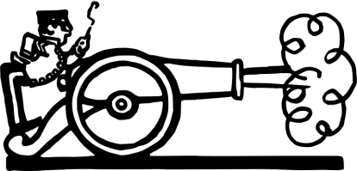

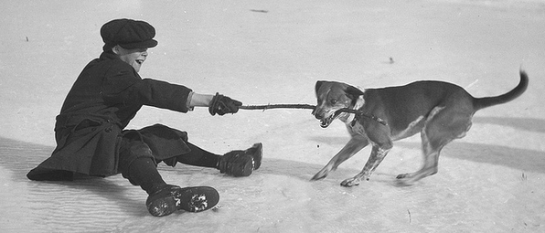

The boy pulls the stick (to the left) (red arrow), and the stick pulls on the boy (blue arrow).
Similarly, the dog pulls the stick (to the right) (blue arrow), and the stick pulls on the dog (to the left) (red arrow). Note that each of the force pairs are equal and opposite.

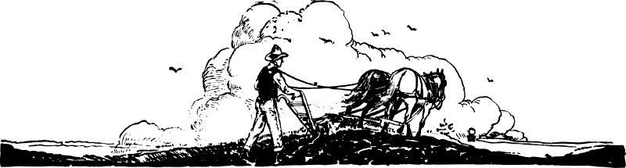

The horses pull the ropes (to the right) (blue arrow), and the ropes pull back on the horses (to the left)
(red arrow). Similarly, the ropes pull the man and his plow forward (to the right) (blue arrow), and the man and the plow pull backwards against this to (to the right) (red arrow). Note that another force pair could be drawn in the soil, between the plow and the soil.

Refer to the following silly pictures, versions A and B, to answer the next few questions:

A 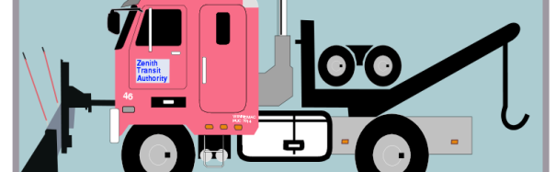

B

- To move the snowman, which snowplow will need to exert more force?
In this problem, the size of the snowman is representative of mass. Snowman B is bigger and thus has greater mass, so it will require more force to move.

- Why?
Since F=ma, the force needed to move the snowman will be greater in B; a proportionally greater force will be needed to move the greater mass of the snow(man).

- The forces are proportional to which of the following:
a) the mass of the snowman b) the volume of the snowman c) the velocity of the snowman

