Let the Blood Flow Student Handout
Example Answers
Pre-Lab Questions
(Note: Answer all questions in lab book or on a separate sheet of paper.)
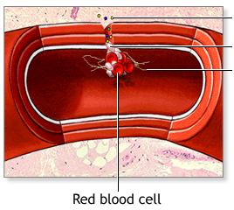
- What is a polymer? How does a polymer form? What type of atom most commonly allows the formation of natural polymers? A polymer is a large molecule composed of repeating units covalently bound to one another. The individual units, or monomers, undergo a chemical reaction resulting in a covalent bond between them. The stringing together of several monomers forms a polymer. Carbon, with its four unpaired electrons, and its ability to share those electrons to form four covalent bonds, results in the formation of simple to complex polymers.
- Is a blood clot a polymer? Is it a protein? A blood clot is essentially a polymer of fibrin monomers. Fibrin monomers combine through covalent linkages to create a fibrin polymer, thus preventing blood from leaking out of holes in blood vessels. As each fibrin monomer is a protein, the combination of many fibrin monomers results in a larger protein. A blood clot is therefore a polymer and a protein.
- What are causes of stroke? Ischemic stroke can occur due to a blockage in the blood vessel as a result of a formed blood clot (thrombosis), or a blood clot or plaque that migrated to block blood flow (embolism). Stroke can also be due to hemorrhage, called hemorrhagic stroke, which is when a weakened blood vessel ruptures and bleeds. This causes blood to accumulate in surrounding brain tissue, causing damage and compression.
- Flow rate is the amount of fluid that flows per unit time: f= Av, where f is the flow rate, A is the cross-sectional area of the pipe/vessel, and v is the speed of the flow. What is the flow rate of blood through a vessel that is 1 cm in diameter moving at 5 cm/s?
f = Av = π(1cm/2)² (5 cm/s) = 3.9 cm³/s
- If the same blood vessel in question 4 has a blood clot that is 2 cm long and 0.7 cm thick, what is its estimated volume in centimeters? What is the new flow rate? What is the difference from your previous answer?
Total volume of the blood vessel over 2 cm length = (cross-sectional area) (length) =
π (1cm/2)² (2cm) = (0.8 cm²) (2cm) = 1.6 cm³
Volume not filled with the blood clot over 2 cm length =
(cross-sectional area) (length) = π (1-0.7cm)/2)² (2cm) = (0.1cm²) (2cm) = 0.2 cm³
Volume of blood clot = 1.6 cm³ – 0.2 cm³ = 1.4 cm³
New flow rate: f = Av = (0.1 cm²) (5 cm/s) = 0.5 cm³/s
The difference in flow rate = 3.9 cm³/s – 0.5 cm³/s = 3.4 cm³/s

Activity Introduction
Some biomedical engineers and scientists focus their research and creativity on developing therapeutic methods to unblock human blood vessels that might lead to ischemic stroke. Investigators typically conduct experiments with models before testing their treatments on humans.
In this activity, your goal is to find a method to unclog the tubing without using mechanical force. Just as biomedical engineers first studied the blood clotting process before developing therapies, you will first experiment with the polymerization of the white clog in the tube.
The white clog is made by mixing polyvinyl acetate (C₄H₆O₂)_{n} with borax (sodium borate, Na₂B4O₇ 10H₂0), to form a rubbery white polymer. Polyvinyl acetate is a large polymer made of vinyl acetate monomers covalently bound together:
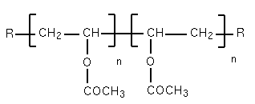

In the presence of water, borax forms the following borate-boric acid buffer system:

When mixed together, the polyvinyl acetate is cross-linked, trapping water, and produces the white clog:
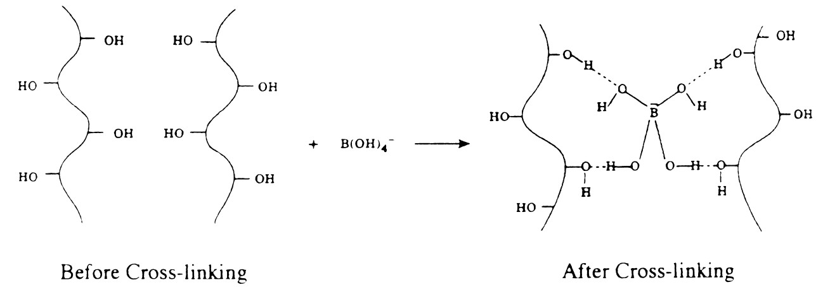

Your Goal
In your biomedical engineering team, determine how to unclog the tube without mechanical force. You may pour ONE liquid solution (up 200 ml) to remove the clog.
Hint: How are researchers currently trying to remove blood clots in stroke patients?
Required Materials List
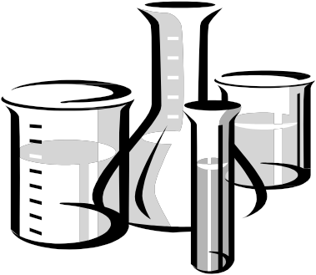
Each group needs:

- 4 paper cups
- 4 wooden stirrers
- clear, flexible tubing
- rubber stopper that fits tubing
- white glue
- 4% borax solution (50 ml)
- graduated cylinder (50 ml)
- water
- marker
- 1 M HCl
- 1 M NaOH
- enzyme solution
- 5% NaCl solution
- glucose solution
- liquid detergent
- 6 test tubes
- 6 droppers or pipettes
- safety goggles, lab apron, gloves

Instructions
Make four polyvinyl acetate polymers of varying concentrations. Record all observations. Make polymers in the paper cups only—do not pour white glue in the graduated cylinder.
- Label the four paper cups as polymers 1, 2, 3, 4.
- Fill the graduated cylinder with 15 ml of water and pour into paper cup 1. Mark the level of the water in the cup. Pour out the water. Mark the same level on the three other cups.
- For each paper cup trial, fill the white glue up to the line on the paper cup. Vary the amounts of borax solution and water based on the table below.
- Stir well and once each polymer is formed, knead for several minutes and continue to observe. Document your observations (color, texture, viscosity, smell, etc.) in the table.
Polymer # | Volume (ml) |  |  | Observations
Polymer # | white glue | water | borax | Observations
1 | To line  (15 ml) | 20 | 5 | Observations may include color,  texture, viscosity, smell, etc.
2 | To line  (15 ml) | 30 | 10 | Observation answers will vary.  Expect students to observe  viscosity differences between the  polymers (a range of liquidy vs. solid).
3 | To line  (15 ml) | 40 | 5
4 | To line  (15 ml) | 40 | 20

- After completing the table, answer the questions, below.
  - Based on your observation, which of the sample polymers in the table do you believe is the same concentration as the “blood clot” in the artery? The correct polymer, the one that is the same concentration as the blood clot in the artery, is Polymer 2.
  - Why? Observations show that this polymer is the same concentration as the blood clot in the artery. Expect student observations to include descriptions of the differences between the polymers based on how liquidy vs. solid they are (or how much force is needed to move or deform the substance). The important observations are the relative variations in viscosity. The correct polymer falls in middle—not the most solid (slow moving, most viscous) and not the most fluid (easy to move, deform, least viscous).
- Develop a liquid solution to unclog artery.
  - Using your knowledge of making polymers and its molecular structure, design an experiment to test how well each of the six liquids (1 M HCl, 1 M NaOH, enzyme solution, 5% NaCl solution, glucose solution, liquid detergent) break down the polyvinyl acetate polymer. Make sure the correct concentration of the polyvinyl acetate polymer (your answer to question 5a) is being used for the tests; if necessary, create more of this sample for testing.
  - Describe your experiment in detail below. Have your teacher approve the experiment before conducting it.
An example experiment: Add a small sample of the polymer to the test tube, and then a sample of one of the liquids. Begin with a few drops of the liquid. If you do not see anything happening, add a few more drops. Record your observations. Empty the test tube contents into the hazardous waste bin and clean out the test tube.
- Now that testing is done, present and demonstrate your method to the entire class. Describe your team’s steps to discover your best liquid solution. Over a bucket, pour your liquid solution into the model artery to show its effectiveness at breaking down the “blood clot.”
Lab Report
Create a lab write-up with the following sections: objective, hypothesis, materials and methods, data, data analysis, discussion and conclusion.
Post-Lab Questions
Answer the following post-lab questions:
- If a blood vessel was clogged with a polyvinyl acetate polymer, would the solution your group found be applicable? Explain. Answers will vary, depending on the success of each group.
- If you were developing a cure or treatment for patients with life-threatening blood clots, what would you need to do before trying it on the actual patients?
Example Answer: From what I learned in this activity, I would first need to recreate the blood clot, or have a sample available of a real blood clot. Then I would test chemicals or solutions to see how they were able to break down the blood clot. I would also want to test how safe the solutions or chemicals are on human tissue and cells. I would try to find a way to apply the solutions or chemicals on living cells and tissues to make sure they are not dangerous to use in a person’s body.

