Post-Activity Assessment Answer Key
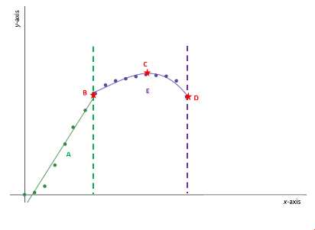
- Given the figure, what does the x-axis represent?
stress
strain
- Given the same figure, what does the region A (between the origin and point B) represent?
ductile strength
load
Young’s Modulus
- Given the same figure, what does point D represent?
yield point
fracture point
load
- Given the same figure, what does point B represent?
fracture point
Young’s Modulus
yield point
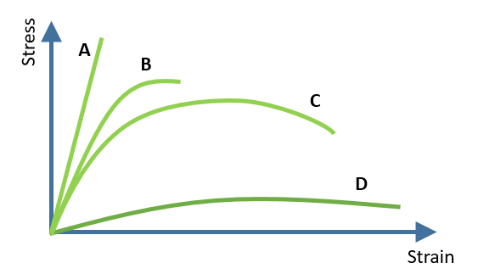
- Given the same figure, if the x-axis represents strain, what does the y-axis represent?
force
displacement
stress
- Given the figure to the right, match the properties to the material:
D plastic
A brittle
B strong, but not ductile
C ductile
- Force per unit area that results from a load applied to a material defines:
stress
strain
- Which is calculated by dividing the change in length of the material by the original length of the material?
stress
strain
- What are the units for stress?
N/m²
Nm²
N/m
Nm
- Which of the following factors does NOT affect the stress on a wire?
diameter of the wire
original length of the wire
load placed on the wire
cross-sectional area of the wire
- Ceramics are brittle:
True
False
- What is the best description of a stress-strain curve for ceramics?
parabola opening up
line
parabola opening down
- Ceramics are ductile:
True
False

