Get the Skinny on LEAN Manufacturing

Motivation / Engineering Connection

Prior to college, most students do not know what is means to be an engineer. Even for those who plan to major in engineering, most typically think in terms of well-known branches of engineering: mechanical, electrical, civil, chemical, biomedical, aeronautical, and possibly computer or materials science. Newer specialties have evolved such as:
- Environmental Engineering
- Food, Agricultural, and Biological Engineering
- Industrial Systems Engineering
By the very nature of their names, students can gain a sense of understanding of the first two. However, the third one probably stumps them or is not immediately appealing due to the lack of understanding.

Industrial and systems engineering is an interdisciplinary field of engineering and management to solve complex problems that oversee a manufacturing process. The job goes beyond the assembly line but delves into the parts suppliers, the distribution of a product, the employees, the processes, the machines, and even the way a facility is designed. An Industrial Systems Engineer studies, and looks to improve upon, work measurement, methods and operations, ergonomics, and inventory.

Engineers tackle work measurement usually via a time study to determine the capacity of a facility in terms of realistic works orders, delivery dates, and costs. Not only does a facility use this knowledge to determine its work force but also to propose alternative methods or to identify the possibility of underperforming employees. They consider things like repetitive versus non-repetitive tasks and what that means for an employee in terms of productivity and mandatory breaks.

Industrial and systems engineers also take a broader look and perform an operational analysis looking for possible work simplification and ways to make continuous improvements. This analysis looks at tooling and machinery, individual workstations, the overall plant layout, and the workplace environments in general through ergonomics. Ergonomics encompasses both the safety and comfort of the employee as well as the consumer. Industrial Systems Engineers also maintain the proper balance of stock to optimize a company’s material handling process.

Although the following activity is primarily concerned with LEAN Manufacturing, a mini-lesson on three common manufacturing buzzwords is in order: Kaizen, Six Sigma, and LEAN Manufacturing. Some companies use all three depending on the situation.

Kaizen is a broad approach to running a company developed by Japanese theorist, Masaaki Imai. It is often described as a business culture, philosophy, or a mindset. It is not a specific tool but a way of operations that rewards ingenuity while practicing to minimize/eliminate waste (muda), find and reduce variation or inconsistency (mura), and identify strain on employees and unnecessary burden on equipment (muri). All employees are trained to operate with a Kaizen state of mind.

Six Sigma was developed by Motorola and focuses specifically on a company’s final product(s). Six Sigma is a tool or set of statistical analysis techniques that are used to minimize defects per opportunity. Instead of an overall mindset like Kaizen, Six Sigma is more like an end goal to minimize variation to strive for near perfection.

LEAN Manufacturing was derived from the Toyota Management System and focuses on a process or a set of processes with a goal of reducing waste and increasing speed and efficiency. LEAN is a management process in which manufacturing efficiency and product quality are equally important. A LEAN facility checks to ensure that each step of a process adds value to efficiency and/or quality. In a LEAN facility, all employees have a voice and each person is valued for their contributions, large or small.

The Math Behind Six Sigma
Have you ever asked a teacher if a grade would be curved? In your mind, you probably think of it as free or extra credit points being added. But do you know what it really means? Many data sets create a bell curve in which 68% of the data falls within plus or minus one standard deviation from the average, 95% of the data falls within two standard deviations, and 99% falls within three standard deviations. When a teacher curves a test grade, that teacher fits the data into a bell curve. This means students who scored at the top of the class, could potentially lose points or receive a letter grade that is lower than what they equate their numeric grade to be. It’s easier to understand the bell curve and standard deviation using some data.
Suppose you surveyed students in your school about the tail length of their pet cats and collected 100 samples.

Length (cm) | Frequency
12 | 1
16 | 1
18 | 1
20 | 2
21 | 3
22 | 7
23 | 22
24 | 28
25 | 23
26 | 5
27 | 3
28 | 2
30 | 1
44 | 1

The average tail length from our sample is 23.97 cm, or 24 cm (rounded to nearest cm) which is calculated as follows:
$$\frac{12+16+18+2\left(20\right)+3\left(21\right)+7\left(22\right)+22\left(23\right)+28\left(24\right)+23\left(25\right)+5\left(26\right)+3\left(27\right)+2\left(28\right)+30+44}{100}$$
$$=23.97≈24$$
The standard deviation is calculated as follows: $σ=\sqrt{\frac{\sum{{(x-\overline{x})}^{2}}}{(n-1)}}=2.99≈3$
$$standard deviation \left(σ\right)=3 cm$$
$$1σ$$
$$2σ$$
$$3σ$$
$$6σ$$
$$1σ$$
$$4σ$$
Where $x=data sample$, $\overline{x}=sample mean$, and $n=sample size$

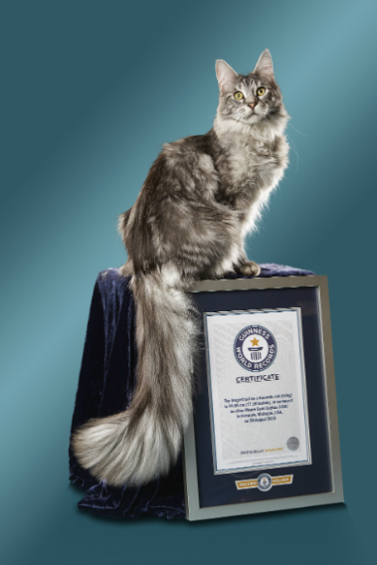
So what does this mean? Standard deviation is a measure of spread from the average. If the standard deviation is low, it means the value is close to the average; if the standard deviation is high, it means the data is dispersed over a wide range of values. Note: standard deviation can only be used when the overall data resembles a bell curve. In other words, in a normal distribution, 68% of the data is generally within ±1σ, 95% within ±2σ, and 99% within ±3σ. If a data point falls within a few standard deviations, one can determine that it is standard or typical. If a data point falls outside of a few standard deviations, one can also conclude that it is unusual or atypical.
Looking at the histogram and standard deviation markings, you should conclude that a 12 cm cat tail is unusual and a 44 cm cat tail is highly unlikely. According to the 2017 Guinness Book of World Records, the longest recorded cat tail belongs to Cygnus Regulus Powers, a silver Maine Coon cat with a tail length of 44.66 cm!

Practice the Math
At your teacher’s direction, you will have one minute to list as many dog breeds as you can. Afterwards, your teacher will list the totals on the board. After all of the data is collected and organized on the board, create a frequency histogram, calculate the mean and standard deviation and then determine how many standard deviations away from the average your own total is. Is anyone outside three sigmas? Why someone may be far below or far above the average in this activity?

Activity Pre-Assessment Questions
Picture a job you are familiar with (either your own or the job of someone you know well):
- Name an action that adds value to a process.
- Name an action that does not add any value and may be considered wasteful.
- Name a step in a process that a customer may consider wasteful but is necessary for a business.

LEAN Activity

Supplies:
- Extra-large plastic Easter eggs
- Face stickers (eyes, nose, mouth, ears, glasses, mustaches)
In your group, divide yourselves into jobs: line supervisor, supplies handler, assemblers (as many as needed), quality control inspector, and warehouse associate. (You can add, subtract, and combine positions as needed.)

For each system production one (four products), record the time from start to finish, the number of opportunities, and the ratio of defects per total opportunities. Finally, determine any wasteful steps or problems with the process and suggest improvements.

NOTE: All left/right designations are from the assembler’s point of view. Do NOT use the large face/body sticker. Instead, use a plastic egg of the designated color for each product.
What is an opportunity? The egg and each sticker procured is an opportunity and the placement of each sticker is another opportunity. Example: Seven stickers and one egg procured, and seven stickers placed results in 15 opportunities.

Group | Product 1 | Product 2 | Product 3 | Product 4
1 | Octopus:  Purple egg  Round eyes  Oval mouth  Star nose  One bubble top of egg  Left hook arm  Mustache | Octopus:  Yellow egg  Red eyes  Smile mouth  One star above left eye  Two bubbles right side of mouth  Pirate hat | Unicorn:  Pink egg  Blue eyes  Lipstick mouth  Rainbow unicorn  Crown  Three hearts on right cheek  Pink hair | Unicorn:  Blue egg  Pink eyes  Plain unicorn  White tooth smile  Rainbow on forehead  Rainbow hair  Wand
2 | Tiger:  Yellow egg  Green eyes  White mouth  Green tie  Long bone across forehead  Large blue star in middle of bone | Tiger:  Blue egg  Pink eyes  Pink oval mouth  Black hat  Scars on left cheek  RAWR sign right side of mouth | Elephant:  Pink egg  Green eyes  Closed mouth sticking out tongue  Hair bow  Peanut on tongue  Short trunk | Elephant:  Purple egg  Blue eyes  Trunk with branch  Black hat  Gritted teeth mouth  Yellow star centered in each ear
3 | Shark:  Blue egg  Green eyes  Captain’s hat  Red smiling mouth  Two small fish in mouth  Three bubbles to the right of mouth | Shark:  Pink egg  Blue eyes  White mouth  Seaweed under mouth  Purple star on right cheek  Three bubble to left of mouth | Monkey:  Yellow egg  Green eyes  Banana hat  Nose with round nostrils  Mouth with tongue sticking out  Banana bubble  Mustache | Monkey:  Purple egg  Blue eyes  Red bow in hair  Nose with narrow nostrils  Open mouth  Yellow star in the middle of each ear
4 | Clownfish:  Yellow egg  Blue eyes  Circular black mouth  Snorkle with bubbles  Purple shell on left side  Pink shell on right side  Pink star for nose | Clownfish:  Blue egg  Goggles  Smiling mouth  Orange hat  Blue fish facing left on left side  Blue fish facing right on right side  Three bubbles coming out of the right side of mouth | Lion:  Purple egg  Golden eyes  Mouth without tongue  Green bandana  Whiskers on both sides  One flower on each ear | Lion:  Pink egg  Blue eyes  Mouth with tongue sticking out (no epiglottis)  Safari hat  One heart as each ear  Scar on left cheek

System 1
System 1 Rules:
- You have three minutes to assign jobs to positions and determine your system.
- The line supervisor cannot touch any materials except the final product.
- Only the supplies handler can obtain materials for the assemblers.
- Record the time it takes assemble your line’s four products.
- Only the warehouse associate can move the product to inventory.
- All products must be accompanied by the quality control checklist.
System 1
Time:
Number of opportunities:
Number of defects:
Ratio of defections to total opportunities:
Wasteful steps and suggestions for improvement:

System 2
In System 2, the materials handler has an image to assist with procuring the necessary supplies. You should see an improvement in this system which you will discuss at the end. There is a catch: switch product lines!

System 2
Time:
Number of opportunities:
Number of defects:
Ratio of defections to total opportunities:
Wasteful steps and suggestions for improvement:

System 3
You will not assemble any products in this system but rather describe what the ideal process would look like.

Post-Activity Assessment Write-Up
Summarize a process at your work or interview a family member about a process at their work. Write a paragraph about how you think the process could be improved or how they can eliminate waste. Be sure to include an introductory paragraph about the type of company (no names necessary) as well as the specific process you are critiquing.

Group 1
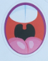  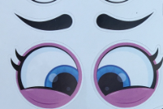  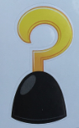 | 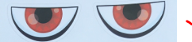  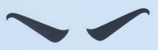  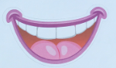  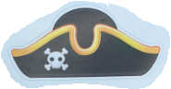
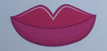  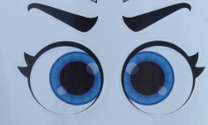  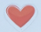  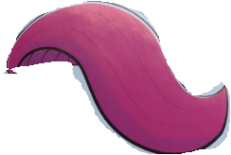  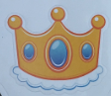  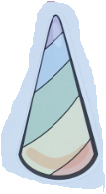 | 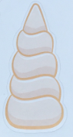  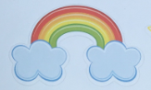  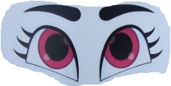

Group 2
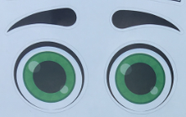  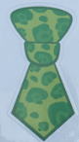 | 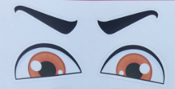  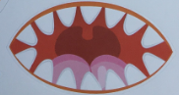  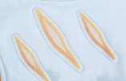  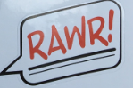
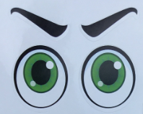  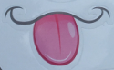  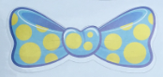  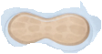  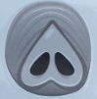 | 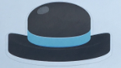  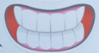

Group 3
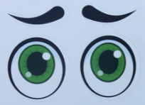  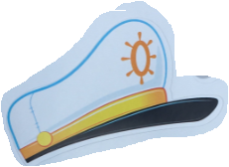  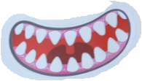  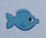 | 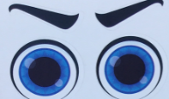  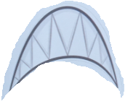  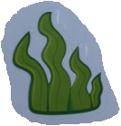  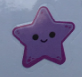
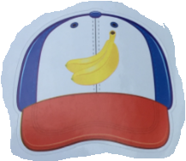  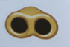  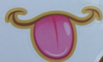  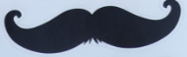  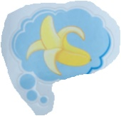  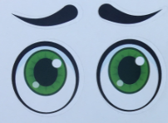 | 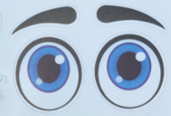  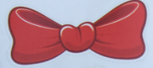  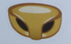  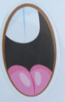  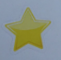

Group 4
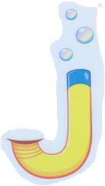  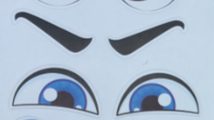  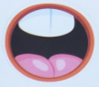  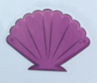  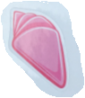  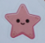 | 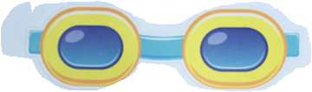  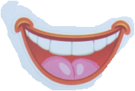  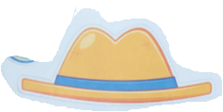  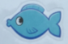  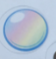
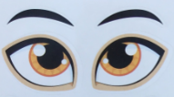  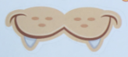 | 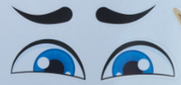  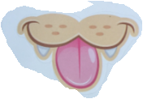  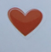

Group 1 / Product 1  Octopus  Purple egg  Round eyes  Oval mouth  Star nose  One bubble top of egg  Left hook arm  Mustache | Group 1 / Product 2  Octopus  Yellow egg  Red eyes  Smile mouth  One star above left eye  Two bubbles right side of mouth  Pirate hat
Group 1 / Product 3  Unicorn  Pink egg  Blue eyes  Lipstick mouth  Rainbow unicorn  Crown  Three hearts on right cheek  Pink hair | Group 1 / Product 4  Unicorn  Blue egg  Pink eyes  Plain unicorn  White tooth smile  Rainbow on forehead  Rainbow hair  Wand

Group 2 / Product 1  Tiger  Yellow egg  Green eyes  White mouth  Green tie  Long bone across forehead  Large blue star in middle of bone | Group 2 / Product 2  Tiger  Blue egg  Pink eyes  Pink oval mouth  Black hat  Scars on left cheek  RAWR sign right side of mouth
Group 2 / Product 3  Elephant  Pink egg  Green eyes  Closed mouth sticking out tongue  Hair bow  Peanut on tongue  Short trunk | Group 2 / Product 4  Elephant  Purple egg  Blue eyes  Trunk with branch  Black hat  Gritted teeth mouth  Yellow star centered in each ear

Group 3 / Product 1  Shark  Blue egg  Green eyes  Captain’s hat  Red smiling mouth  Two small fish in mouth  Three bubbles to the right of mouth | Group 3 / Product 2  Shark  Pink egg  Blue eyes  White mouth  Seaweed under mouth  Purple star on right cheek  Three bubble to left of mouth
Group 3 / Product 3  Monkey  Yellow egg  Green eyes  Banana hat  Nose with round nostrils  Mouth with tongue sticking out  Banana bubble  Mustache | Group 3 / Product 4  Monkey  Purple egg  Blue eyes  Red bow in hair  Nose with narrow nostrils  Open mouth  Yellow star in the middle of each ear

Group 4 / Product 1  Clownfish  Yellow egg  Blue eyes  Circular black mouth  Snorkle with bubbles  Purple shell on left side  Pink shell on right side  Pink star for nose | Group 4 / Product 2  Clownfish  Blue egg  Goggles  Smiling mouth  Orange hat  Blue fish facing left on left side  Blue fish facing right on right side  Three bubbles coming out of the right side of mouth
Group 4 / Product 3  Lion  Purple egg  Golden eyes  Mouth without tongue  Green bandana  Whiskers on both sides  One flower on each ear | Group 4 / Product 4  Lion  Pink egg  Blue eyes  Mouth with tongue sticking out (no epiglottis)  Safari hat  One heart as each ear  Scar on left cheek

Group 1 / Product 1  Octopus  Quality Control Checklist  Purple egg  Round eyes  Oval mouth  Star nose  One bubble top of egg  Left hook arm  Mustache | Group 1 / Product 2  Octopus  Quality Control Checklist  Yellow egg  Red eyes  Smile mouth  One star above left eye  Two bubbles right side of mouth  Pirate hat
Group 1 / Product 3  Unicorn  Quality Control Checklist  Pink egg  Blue eyes  Lipstick mouth  Rainbow unicorn  Crown  Three hearts on right cheek  Pink hair | Group 1 / Product 4  Unicorn  Quality Control Checklist  Blue egg  Pink eyes  Plain unicorn  White tooth smile  Rainbow on forehead  Rainbow hair  Wand

Group 2 / Product 1  Tiger  Quality Control Checklist  Yellow egg  Green eyes  White mouth  Green tie  Long bone across forehead  Large blue star in middle of bone | Group 2 / Product 2  Tiger  Quality Control Checklist  Blue egg  Pink eyes  Pink oval mouth  Black hat  Scars on left cheek  RAWR sign right side of mouth
Group 2 / Product 3  Elephant  Quality Control Checklist  Pink egg  Green eyes  Closed mouth sticking out tongue  Hair bow  Peanut on tongue  Short trunk | Group 2 / Product 4  Elephant  Quality Control Checklist  Purple egg  Blue eyes  Trunk with branch  Black hat  Gritted teeth mouth  Yellow star centered in each ear

Group 3 / Product 1  Shark  Quality Control Checklist  Blue egg  Green eyes  Captain’s hat  Red smiling mouth  Two small fish in mouth  Three bubbles to the right of mouth | Group 3 / Product 2  Shark  Quality Control Checklist  Pink egg  Blue eyes  White mouth  Seaweed under mouth  Purple star on right cheek  Three bubble to left of mouth
Group 3 / Product 3  Monkey  Quality Control Checklist  Yellow egg  Green eyes  Banana hat  Nose with round nostrils  Mouth with tongue sticking out  Banana bubble  Mustache | Group 3 / Product 4  Monkey  Quality Control Checklist  Purple egg  Blue eyes  Red bow in hair  Nose with narrow nostrils  Open mouth  Yellow star in the middle of each ear

Group 4 / Product 1  Clownfish  Quality Control Checklist  Yellow egg  Blue eyes  Circular black mouth  Snorkle with bubbles  Purple shell on left side  Pink shell on right side  Pink star for nose | Group 4 / Product 2  Clownfish  Quality Control Checklist  Blue egg  Goggles  Smiling mouth  Orange hat  Blue fish facing left on left side  Blue fish facing right on right side  Three bubbles coming out of the right side of mouth
Group 4 / Product 3  Lion  Quality Control Checklist  Purple egg  Golden eyes  Mouth without tongue  Green bandana  Whiskers on both sides  One flower on each ear | Group 4 / Product 4  Lion  Quality Control Checklist  Pink egg  Blue eyes  Mouth with tongue sticking out (no epiglottis)  Safari hat  One heart as each ear  Scar on left cheek

