Activity Part 2 Worksheet: FSRs and Arduino

Equipment Needed:
- All materials from Activity 1.
- One more jumper wire
- One 10 kΩ resistor
- One Arduino microcontroller and corresponding USB cable
- Desmos IDE or TI-84

Objective:
- Calculate the voltage across a pull-up resistor
- Build a voltage-divider circuit
- Map digital values to analog voltage equivalents
- Read a manufacturer datasheet
- Use curve fitting to interpret/predict data
Procedure:
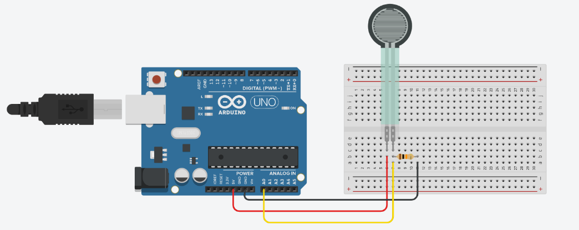
- Reusing the materials from Activity 1, remove the multimeter connections from the FSR and re-purpose the two jumpers wires to connect to 5V and ground (GND) on the Arduino microcontroller. Add a 10 kΩ resistor between the FSR terminal connected to ground and another rail on the breadboard. Connect the other end of the 10 kΩ resistor to the microcontroller's analog input (A0).
- Recall that the voltage at the analog input A0 is really the voltage across the pull-down resistor. Remember: the voltage across the pull-down resistor can be calculated from the following equation:
$Vo=V_{in}\frac{R_{2}}{R_{2}+R_{1}}$, where $V_{in}=5 V$, $R_{2}=10 k$, and $R_{1}$ is the resistance of the FSR.
The voltage across the FSR can be similarly calculated:
$$V_{1}=V_{in}\frac{R_{1}}{R_{1}+R_{2}}$$

Given an FSR resistance of 25 kΩ, calculate the voltage across the FSR and across the pull-up resistor. Also, calculate the percentage of the input voltage across the resistor. What do you notice?
Voltage divider circuit practice example
 | R1 (FSR) | R2 (pull-up resistor) and input to A0
Voltage across
Percentage of voltage across

- Now that you are comfortable with voltage-divider circuits, complete the chart below for the given FSR values you recorded in the Part 1 Activity worksheet. Arduino boards have a built-in analog-to-digital converter. When you code an analogRead() line, the analog voltage from 0‒5 V is converted to the digital integer values (discrete values) from 0‒1023. Convert the calculated voltages to their expected digital values between 0‒1023, using a proportion, and record the results in the chart. Important: Many people think that because 1023 is the highest digital value, that it will be used in the proportional conversion but you must consider the number of increments which is 1024 increments. That means each voltage interval is 5 V / 1024 units. This means that a 0 digital reading represents a voltage between 0‒0.0049 V. At the other end, 1023 represents a voltage 4.995‒5.000 V.
Calculated/expected values of voltage-divider circuit
Pressure | V_{in} | R2 Value  (pull-up resistor) | R1 Value  (FSR) | Calculate V_{o} | Expected Digital Value
Light touch | 5 V | 10 kΩ
Medium Touch | 5 V | 10 kΩ
Hard Press | 5 V | 10 kΩ

- Open up the Arduino IDE and create a sketch to display the digital values as well as the voltage values in mV. Feel free to use the example code shown below.
- Save your sketch, upload the code to the microcontroller, and then open the Arduino serial monitor so you can see your results.
- Repeat the pressure test from step 3 and record your measurements. The Arduino map function is doing the proportional conversion of digital values to voltage values in mV. Show how you would use mathematics to convert the digital value 475 to mV. How would you code this in Arduino in lieu of the map() command?
Measured values of voltage-divider circuit
Physical Pressure Applied to FSR | Measured Digital Values | Measured Analog Voltage (mV)
Light touch
Medium touch
Hard press

Sample code:

int FSRpin = 0;
int FSRval; //the digital values 0-1023
float fsrVoltage; // the analog sensor reading converted to digital voltage 0 - 5 V or 0 – 5000 mV
void setup() {
Serial.begin(9600);
pinMode(FSRpin, OUTPUT);
}
void loop() {
FSRval = analogRead(FSRpin);
Serial.print("Digital Value = ");
Serial.println(FSRval);
// analog voltage reading ranges from about 0 to 1023 which maps to 0V to 5V (= 5000mV)
fsrVoltage = map(FSRval, 0, 1023, 0, 5000);
Serial.print("Voltage reading in mV = ");
Serial.println(fsrVoltage);

delay(1000);
}

Sample Output
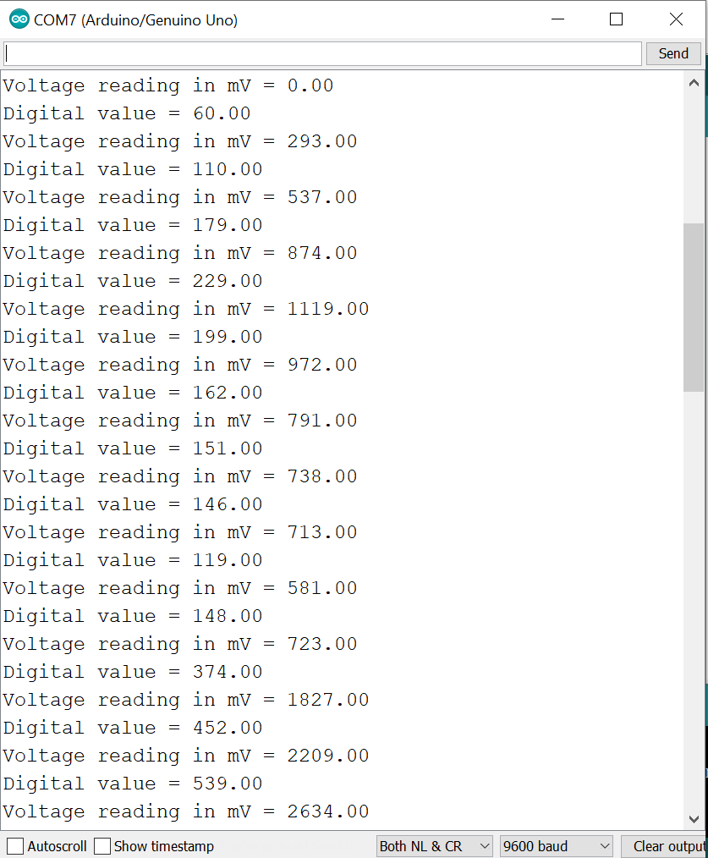
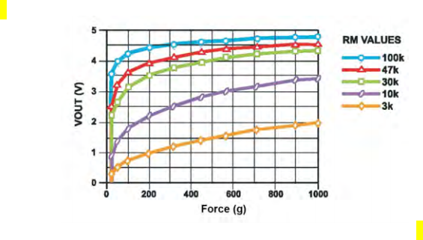
- You can determine an approximate force in grams (and then convert to Newtons) using the data sheet provided by the manufacturer (Interlink pdf). These sensors are not designed to measure weight but rather relative changes in resistance. However, based on the manufacturer's datasheet you can use curve fitting and regression to make an approximation. Interlink's datasheet shows the voltage-force relationship for five different pull-down resistor values.
- Locate the curve corresponding to the resistor value for the voltage-divider circuit you built. Record your data estimations in the table below. (Your values will be estimations from the figure.) Record at least ten data points; add rows if needed. Since you know the voltage, you are interested in as force as a function of voltage. How will this affect your table in Desmos or your Ti-84 graphing calculator?
- Using Desmos (or other app) enter the table and graph a scatterplot. Adjust your window as needed.
Force-voltage value estimates from the manufacturer's datasheet
Force (g) | Voltage (V) | Force (g) | Voltage (V)
- You will have to run several regressions before determining the appropriate curve. Is it linear, quadratic, or a higher order polynomial (order 3 or 4)? Is it logarithmic? Is it exponential? Complete the chart below with your data values as well as the $R^{2}$ values you obtain. (Once you settle on the curve of best fit, circle it and write the equation in the Results column. Draw X’s in the other cells.)
Desmos regression models.
Parent Function | Desmos Regression Model | R² | Result
Linear | $$y_{1}\sim ax_{1}+b$$
Quadratic | $$y_{1}\sim a{x_{1}}^{2}+bx_{1}+c$$
Cubic | $$y_{1}\sim a{x_{1}}^{3}+b{x_{1}}^{2}+{cx}_{1}+d$$
Quartic | $$y_{1}\sim a{x_{1}}^{4}+b{x_{1}}^{3}+c{x_{1}}^{2}+dx_{1}+e$$
Exponential | $$y_{1}\sim ab^{x_{1}}+c$$
Logarithmic | $$y_{1}\sim alog\left(x_{1}\right)+b$$

- Convert your light touch, medium touch, and hard press values into force values. Use your regression function, the voltages recorded in step 5, and the gram-Newton conversion information.
NOTE: $1 gram=0.00980665 Newtons$
Approximate pressure values.
Pressure | Voltage | Approximate grams | Approximate Newtons
Light touch
Medium touch
Hard press

