Post-Assessment Answer Key

- Draw arrowheads on the lines to indicate the relationship between all of the measurements.
Pressure | Resistance | Current | Voltage

- How many decimal values can be represented with a 5-bit byte? If the first value is 0, what is the last value? $2^{5}=32$, therefore values are in the range 0‒31.

- What ASCII character is represented by the decimal value 10? LF or line feed.

- List the decimal values for the ASCII characters in the string "ARDUINO."
A = 65, R = 82, D = 68, U = 85, I = 73, N = 78, 0 = 79

- If an Arduino board sends serial data to an Android tablet or smartphone, which of the following should be true in order to avoid buffering and/or lost data?
a) Arduino delay < app clock timer
b) Arduino delay = app clock timer
c.) Arduino delay > app clock timer

- Match the symbol to the component name:
Resistor | Ground | Battery Voltage Source
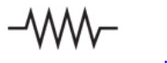 | 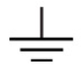 | 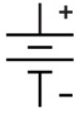

- What are the colored bands for a 10 kΩ 3-band resistor? Brown/Black/Orange
A 5-band? Brown/Black/Black/Red/(silver or gold)
- Design a voltage divider circuit where the voltage across the top resistor is 25% of the total input and the voltage across the bottom resistor is 75% of the total input. Draw a sketch and label the input voltage and both resistor values. Answers will vary but the bottom resistor should be one-fourth of the sum of the resistors and the bottom should be three-fourth of the total.
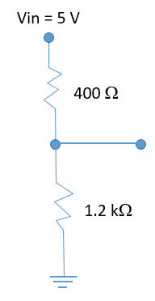
- If an MIT App Inventor 2 canvas is 300 pixels wide and you want to plot a data point every two pixels, how many data points can you plot?
$$\frac{300 pixels}{2 \frac{pixels}{data point}}=150 points$$
If you are planning to plot digital values (0‒1023), and the canvas is 150 pixels high, what equation will you use to scale the values for the canvas?
$$ScaledValue= \frac{DigitalValue∙150 pixels}{1023}$$

What if you decide to plot 0‒5000 mV? What is your scaling equation now?
$$Scaled Value= \frac{mVValue∙150 pixels}{5000}$$

