Pneumatics Lab Set-Up Photos
The components of a pneumatic circuit ⬇
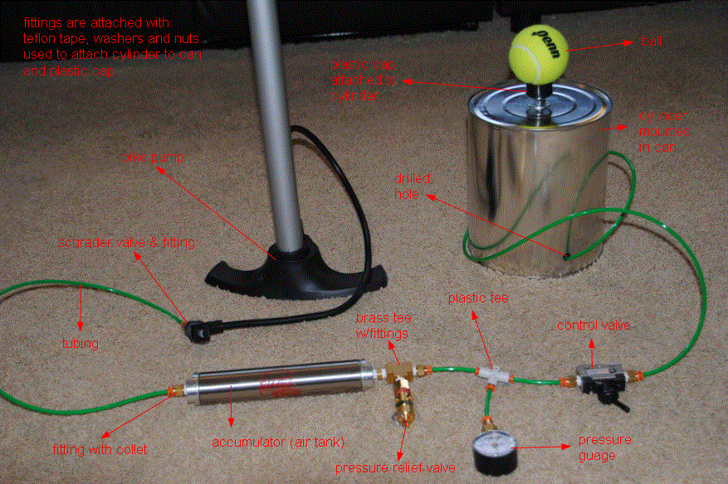
Attach fittings with Teflon tape.
Use washers and nuts to attach cylinder to can and plastic cap.

ball

plastic cap attached to cylinder

cylinder mounted
in can

bike pump

drilled hole

Schrader valve & fitting

plastic tee

tubing

brass tee with fittings

control valve

fitting with collet

accumulator (air tank)

pressure gauge

pressure relief valve

The inside of the paint can with mounted cylinder and parts ⬇
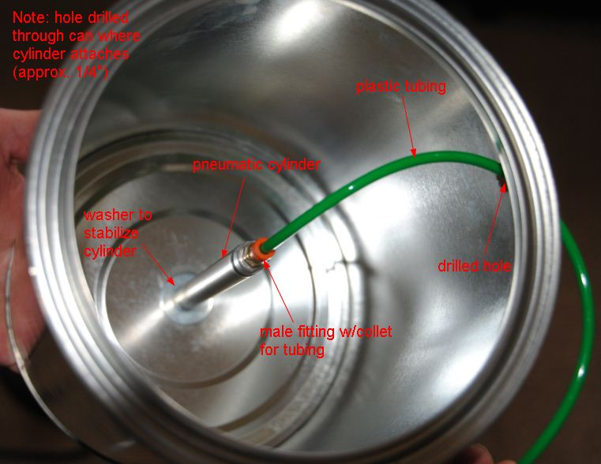
Attach the cylinder in a hole drilled through the can (approx. ¼-in)

plastic tubing

pneumatic cylinder

Use a washer to stabilize the cylinder

drilled hole

male fitting with
collet for tubing

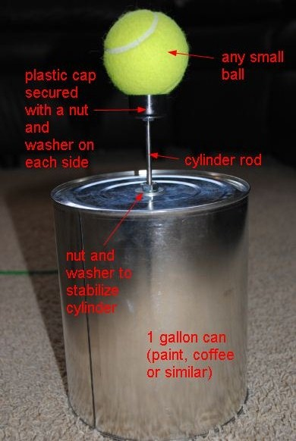
The outside of the paint can with the cylinder
extended and supporting a tennis ball ➔
Use any small ball

Secure the plastic cap with a nut and washer on each side

cylinder rod

one-gallon can (such as a paint or coffee can)

Use a nut and washer to stabilize the cylinder

