GAMMA
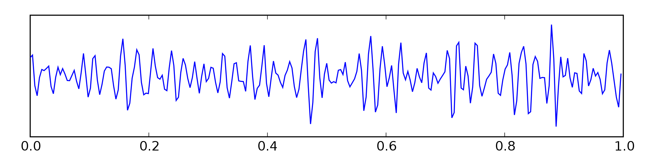

BETA
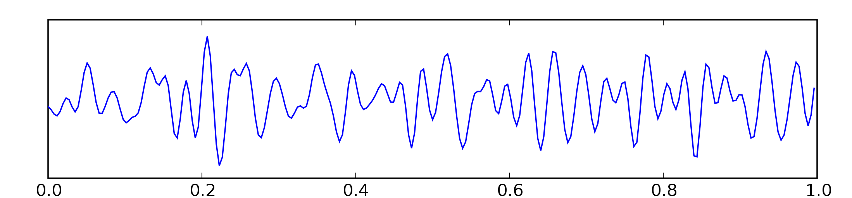

ALPHA
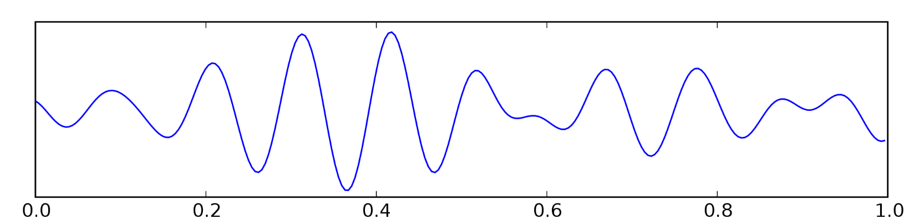

THETA
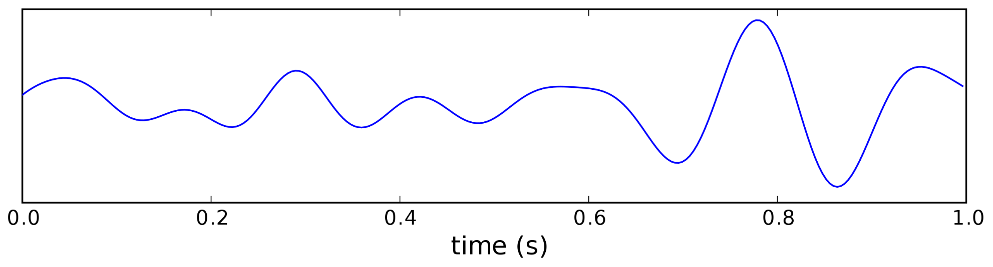

DELTA
