What is an ECG? Jupyter Notebook Activity Answer Key

Directions
Open the file WhatIsAnECG_NOTEBOOK.ipynb in Google Colaboratory by selecting “File->Open Notebook” (NOTE: You will need a Google Account to use Google Colaboratory.) Read each cell (block) of text and run each cell of code by clicking the play button on the left side of the block as indicated by the red circle in the figure below.

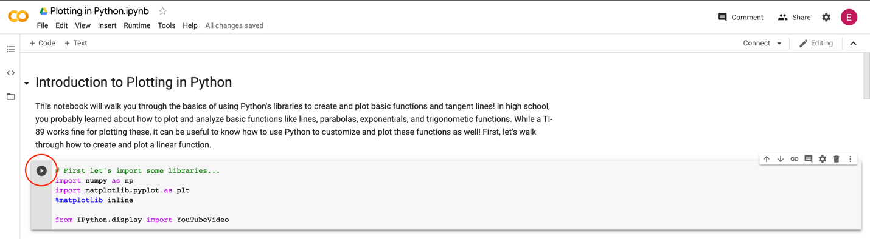

Important note: The data you will examine in this worksheet is actual ECG data collected for research. This data will not perfectly resemble the waves we saw in the slides—there is noise in the data, making it harder to read. When you complete this notebook and worksheet, keep this in mind!

As you read, watch, and run each cell, answer the following questions. This is a graded assignment.

- ECG Background. Watch the video on “ECG Basics” by Osmosis that is linked in the notebook.

  - What does an ECG measure?
The electrical activity of the heart

  - Briefly describe how an electrical signal flows through the heart at the cellular level. (HINT: Go to the 1:00 timestamp in the video.)
The cells of the heart depolarize (the voltage of the inside of the cell goes from being negative to positive), one after the other—this depolarization continues to travel down the heart (in other words, the signal travels down the heart)

  - How can a doctor determine if a heart issue is present in a specific area of the heart? (HINT: Think about how the ECG is being measured.)
The doctor can measure the ECG at different areas of the heart and compare all the waves to one another—if one wave shows some major differences from the rest, there may be an issue with the area of the heart associated with that wave.

- Examining your first ECG data. Run the first code block. When you are prompted to open a file, select ECG_Example1.csv. Then, run the remaining two code blocks to view the plot.

  - Move the Zoom horizontal slider all the way to the right and move the X position slider so that the x range in the plot is about [2.0, 3.0]. Compared with other segments of the plot, does this segment have more electrical activity or less electrical activity? How do you know? (HINT: Think about peak magnitude/height.)
The segment at [2.0, 3.0] is slightly less active (small height/magnitude compared to other segments)

  - Move the X position slider until you find a portion with a recognizable ECG wave like the one shown at the top of the notebook (NOTE: it won’t be perfect, just find a pattern that looks similar). Sketch the wave segment below and label the values on the x-axis.
Any answer is acceptable, as long as the student completes both the sketch and axis labels.

- Examining more ECG data. Now, re-run the first code block. When you are prompted to open a file, select ECG_Example2.csv. Then, run the remaining two code blocks to view the plot.

  - Move the Zoom horizontal slider all the way to the right and move the X position slider so that the x range in the plot is about [38.0, 39.0]. Compared with other segments of the plot, does this segment have more electrical activity or less electrical activity? How do you know? (HINT: Think about the peak magnitude/height.)
This segment has a higher average peak magnitude/height than the other segments

  - Compare this segment to the segment you analyzed in Problem 2a from ECG_Example1. How is this segment different from the previous segment? (HINT: Think about peak magnitude/height—you may need to re-run the code with ECG_Example1.)
This segment has a much higher average peak magnitude/height (~0.6) than the segment from the previous example (~0.3)

  - Move the X position slider until you find a portion with a recognizable ECG wave like the one shown at the top of the notebook (NOTE: it won’t be perfect, just find a pattern that looks similar). Sketch the wave segment below and label the values on the x-axis.
Any answer is acceptable, as long as the student completes both the sketch and axis labels.

