What is an EMG? Jupyter Notebook Activity
Directions
Open the file WhatIsAnEMG_NOTEBOOK.ipynb in Google Colaboratory by selecting “File->Open Notebook” (NOTE: You will need a Google Account to use Google Colaboratory.) Read each cell (block) of text and run each cell of code by clicking the play button on the left side of the block as indicated by the red circle in the figure below.

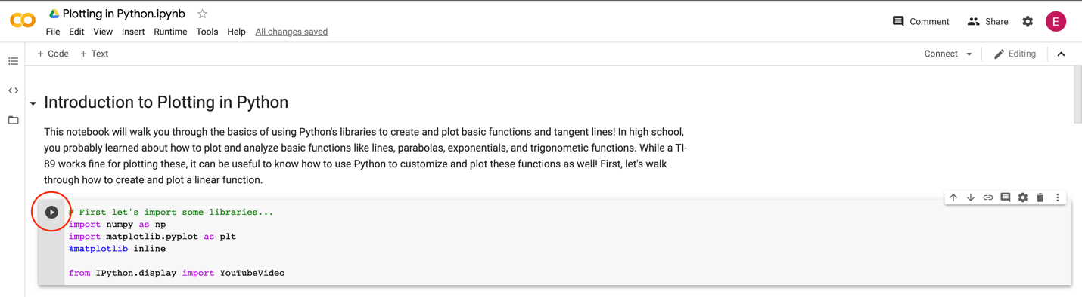

Important note: The data you will examine in this worksheet is actual EMG data collected for research. This data will not perfectly resemble the waves we saw in the slides—there is noise in the data, making it harder to read. When you complete this notebook and worksheet, keep this in mind!

As you read, watch, and run each cell, answer the following questions. This is a graded assignment.

- EMG Background. Watch the video on “EMG” by Mayfield Brain and Spine that is linked in the notebook.

  - What does an EMG measure?

  - What are the two types of neurons in the body? Briefly describe each. (HINT: Go to the 1:30 timestamp in the video.)

  - Describe how the EMG changes when the patient bends their wrist. Does this result in more or less activity in the EMG? (HINT: Go to the 10:00 timestamp in the video.)

- Examining your first EMG data. Run the first code block. When you are prompted to open a file, select EMG_Example1.csv. Then, run the remaining two code blocks to view the plot.

  - Move the Zoom horizontal slider all the way to the right and move the X position slider so that the x range in the plot is about [14.0,15.0]. Compared with other segments of the plot, does this segment have more electrical activity or less electrical activity? How do you know? (HINT: Think about the peak magnitude/height.)

  - Move the X position slider until you find a portion with a mix of low and high muscular activity (NOTE: it won’t be perfect, just find a pattern that looks similar). Sketch the wave segment below and label the values on the x-axis.

- Examining more EMG data. Now, re-run the first code block. When you are prompted to open a file, select EMG_Example2.csv. Then, run the remaining two code blocks to view the plot.

  - Adjust the X position and Zoom Horizontal sliders until the x range in the plot is about [1.0, 4.0] Which half of this segment involves greater activation of the muscle being measured? How do you know? (HINT: Think about the peak magnitude/height.)

  - Move the X position slider until you find a portion with a mix of low and high muscular activity (NOTE: it won’t be perfect, just find a pattern that looks similar). Sketch the wave segment below and label the values on the x-axis.

