What is an EMG? Post-Quiz Answer Key

Directions
Answer the following questions the best you can. This is a graded assignment.

- What is an EMG? In 2-3 sentences, please explain what EMG stands for, how you would define it, and provide one example for why they are important.
EMG stands for electromyograph, and it is a measurement of the electrical activity of the muscles. EMG can help diagnose or monitor neuromuscular disorders, assess the health of a muscle, and be used in research to study muscular function. (Any one of these answers, along with any valid answer, should receive full credit.)

- Fill in the blanks of the following sentence:

Action potentials are electrical signals generated by our neurons to convey information.

- Please draw a picture of the waves an oscilloscope might display for a normal, healthy muscle at three different levels of contraction:

Rest | Slight Contraction | Forceful Contraction
Flat line—little to no activity | 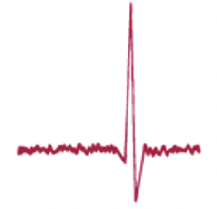  Single, or few, spike(s) | Several spikes

- What are the two primary types of motor neurons? Use them to fill in the following statement:

Upper motor neurons originate in the brain and send information to… lower motor neurons, which are attached to our muscles.

