Engineering Design Process Worksheet

Instructions: Using the engineering design process, you and your team will act as biomedical engineers who are tasked with creating a micro:bit experiment that shows how different body parts require different levels of neural recruitment.
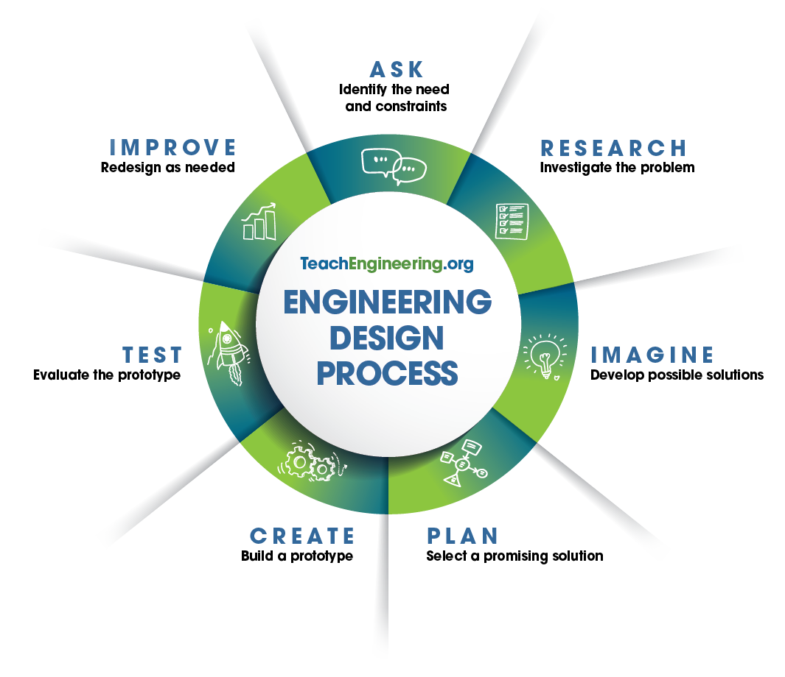

- Ask – Identify the need and constraints of the problem.
____________________________________________________________________________
____________________________________________________________________________
____________________________________________________________________________
____________________________________________________________________________

- Research – What do you know about basic neuroscience? (Hint: What did you learn from Handouts 1, 2, and 3?)
____________________________________________________________________________

____________________________________________________________________________
____________________________________________________________________________

____________________________________________________________________________
____________________________________________________________________________

____________________________________________________________________________

____________________________________________________________________________
- Imagine – Individually sketch out four possible solutions.

a | b
c | d
- Plan – Have each team member share their ideas. As a team, select ONE solution. This can be one specific solution or a mixture of ideas. Draw your team’s solution in the box below.

- Create – Build your prototype as shown in your group’s drawings.

- Test – Test your design and then answer the following questions.

What worked in your design, and why?

____________________________________________________________________________
____________________________________________________________________________
____________________________________________________________________________
____________________________________________________________________________
____________________________________________________________________________

What did not work in your design, and why?

____________________________________________________________________________
____________________________________________________________________________
____________________________________________________________________________
____________________________________________________________________________
____________________________________________________________________________

- Improve – Based on your testing and results, how would you improve your design? Why?

____________________________________________________________________________
____________________________________________________________________________
____________________________________________________________________________
____________________________________________________________________________
____________________________________________________________________________
____________________________________________________________________________
____________________________________________________________________________

- (optional) Iterate – Make changes and retest your updated prototype.

Did your changes improve your prototype? How?
____________________________________________________________________________
____________________________________________________________________________
____________________________________________________________________________

What worked in your updated design, and why?

____________________________________________________________________________
____________________________________________________________________________
____________________________________________________________________________
What did not work in your updated design, and why?

____________________________________________________________________________
____________________________________________________________________________
____________________________________________________________________________

