Handout 1: Basic Brain Information Answer Key

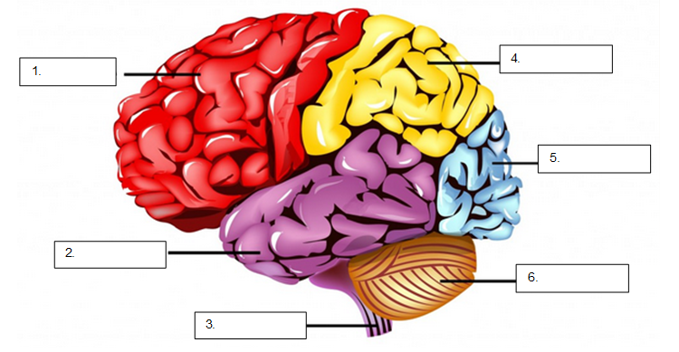
https://commons.wikimedia.org/wiki/File:Brain_lobes_and_regions_with_labels.png

- Match the parts of the brain with the terms given:
  - Parietal lobe 4
  - Occipital lobe 5
  - Frontal lobe 1
  - Temporal lobe 2
  - Cerebellum 6
  - Spinal cord 3

- State the function of each part below:
The brain's hemispheres have four lobes. The functions are listed below.
Ref: https://www.mayoclinic.org/diseases-conditions/epilepsy/in-depth/brain/art-20546821
Mayo Clinic. (2024, July 2). How your brain controls everything from your heart rate to your mood.https://www.mayoclinic.org/diseases-conditions/epilepsy/in-depth/brain/art-20546821

  - Parietal lobe
The parietal lobes help interpret feeling, known as sensory information. The lobes process taste, texture, and temperature.

  - Occipital lobe
The occipital lobes process images from your eyes and connect them to the images stored in your memory. This allows you to recognize images.
  - Frontal lobe
The frontal lobes help control thinking, planning, organizing, problem-solving, short-term memory, and movement.

  - Temporal lobe
The temporal lobes help process information from your senses of smell, taste, and sound. They also play a role in memory storage.

  - Cerebellum
The cerebellum is a wrinkled ball of tissue below and behind the rest of the brain. It works to combine sensory information from the eyes, ears, and muscles to help coordinate movement. The cerebellum activates when you learn to play the piano, for example.

  - Spinal cord
The spinal cord carries nerve signals from the brain to help us move and feel sensations.

- What part of the brain is involved with movement? Give an example.
The cerebellum is responsible for movement, balance, and coordination. Examples are learning to play an instrument or riding a bike.

