Handout 1: Basic Brain Information

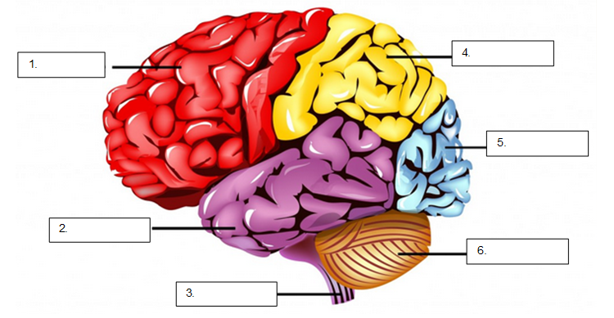
https://commons.wikimedia.org/wiki/File:Brain_lobes_and_regions_with_labels.png

- Match the parts of the brain with the terms given:
  - Parietal lobe
  - Occipital lobe
  - Frontal lobe
  - Temporal lobe
  - Cerebellum
  - Spinal cord

- State the function of each part below:
  - Parietal lobe

  - Occipital lobe

  - Frontal lobe

  - Temporal lobe

  - Cerebellum

  - Spinal cord

3. What part of the brain is involved with movement? Give an example.

