Handout 2: Neurons and Neuron Recruitment for Muscle Work
Answer Key

- Look at the picture of a neuron below. Describe what each structure of the neuron is responsible for.
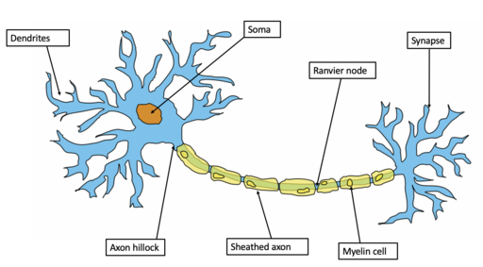
https://commons.wikimedia.org/wiki/File:Example_of_a_neuron.png

Dendrites are the receivers of information from other neurons and carry the information to the current neuron.

Nucleus controls the neuron and tells it what to do.

Soma (cell body) is the brain of the neuron.

Axon is the long part of the neuron down which electrical impulses travel.

Myelin sheaths allow electrical impulses to travel quickly and efficiently along the neuron.

Axon terminals transmit messages to other cells through neurotransmitters at the neuromuscular junction or synapse.

- What is a neurotransmitter? Give one or two examples. What do you think happens if you have too much or too little of the neurotransmitter?

Neurotransmitters are chemicals that enable neuron communication in the body. Examples are dopamine and acetylcholine.

Too much neurotransmitter can cause sudden firing of neurons in the brain, which can cause seizures.

Too little neurotransmitter can cause difficulty completing tasks, lack of motivation, and poor concentration.
- Below is a picture of a synapse. In your own words, describe what is happening at the synapse.

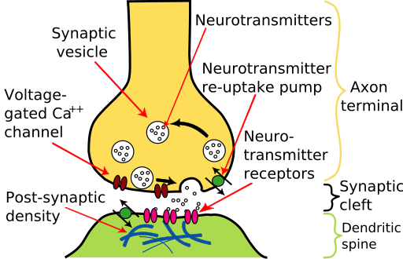
https://commons.wikimedia.org/wiki/File:Synapse_diagram_picture.jpg

At the synapse, the neurotransmitter is being released from the axon terminal of the first neuron (presynaptic neuron) at the synapse or synaptic cleft and attaches to its appropriate receptor at the second neuron (post synaptic neuron). Neurotransmitters are stored in sacs in neurons called synaptic vesicles. A transporter molecule helps the neurotransmitter go into the synaptic cleft. The released neurotransmitter attaches to its receptor in the dendrite of the second neuron and is conveyed to its axon for further conveyance to other neurons. The voltage-gated calcium channel is responsible for and helps facilitate the process of neurotransmitter release. The post-synaptic density helps neurotransmitter receptors of the post-synaptic neuron congregate and organize in the synaptic cleft (synapse).

- Watch one or both of the following videos and summarize in a few sentences how neurons are recruited for muscle activity, and how this recruitment can be increased or decreased.
https://www.youtube.com/watch?v=1E3MLkvnCME
https://www.youtube.com/watch?v=UnNGGD4-IHU

Answers will vary.
Potential answer: Neurons are recruited for muscle activity through motor units, which are groups of muscle fibers controlled by a single motor neuron. The body recruits motor units in order of size, starting with small ones for light, precise movements and adding larger ones as more force is needed—this is called the size principle. Muscle force can be increased by recruiting more motor units or by having the active neurons fire more rapidly. To decrease force, the nervous system reduces the number of active motor units or slows their firing rate.

- Give one example from your life today of how neuron recruitment works.
Examples could include using jaw muscles to chew a marshmallow versus hard candy, or using arm muscles to lift weights versus holding a book to read.

