Handout 2: Neurons and Neuron Recruitment for Muscle Work

- Look at the picture of a neuron below. Describe what each structure of the neuron is responsible for.
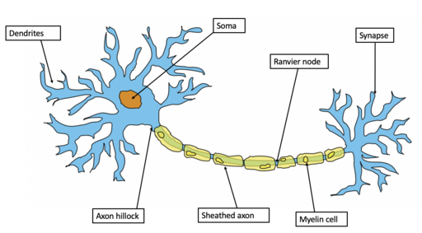
https://commons.wikimedia.org/wiki/File:Example_of_a_neuron.png

- What is a neurotransmitter? Give one or two examples. What do you think happens if you have too much or too little of the neurotransmitter?

- Below is a picture of a synapse. In your own words, describe what is happening at the synapse.

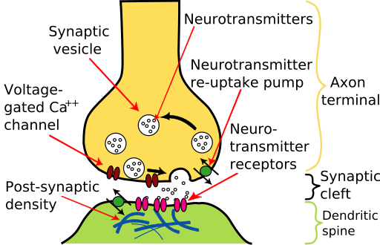
https://commons.wikimedia.org/wiki/File:Synapse_diagram_picture.jpg

- Watch one or both of the following videos and summarize in a few sentences how neurons are recruited for muscle activity, and how this recruitment can be increased or decreased.

https://www.youtube.com/watch?v=1E3MLkvnCME

https://www.youtube.com/watch?v=UnNGGD4-IHU

- Give one example from your life today of how neuron recruitment works.

