Handout 3: Drawing a Homunculus and Getting Familiar with the Micro:bit Answer Key

Draw a Homunculus

Instructions: In the space below, draw a cross section of the brain and label the parts of the brain with the muscle movement they control.
Answers will vary. Try to have students get to a diagram such as the one below.
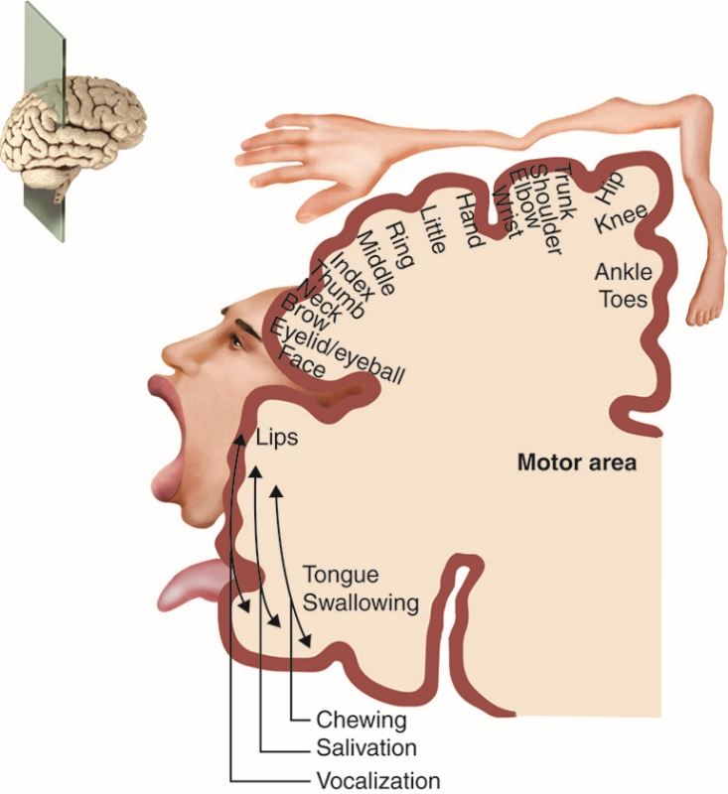

https://commons.wikimedia.org/wiki/File:Anatomytool_Sensory_homunculus_English.jpg

Notes for the teacher: The main areas shown are the somatosensory cortex and the motor cortex.

The somatosensory cortex is the part of the brain within the cerebral cortex, which receives all sensory information from different parts of the body. Its function is to process somatic sensations from receptors throughout the body that are responsible for detecting touch, proprioception (i.e., the position of the body in space), nociception (i.e., pain), and temperature.

The motor cortex is an area of the frontal lobe and is the part of the brain that is involved in planning, control, and execution of voluntary movements. Damage to the motor cortex results in the individual being unable to move their fingers precisely to make individual movements such as writing, tying knots, etc.

Get Familiar With the Micro:bit

Group Activity Instructions
- Gather your materials: computer or laptop, 1 micro:bit, and a timer.
- Input the following code (either Python or MakeCode) on your computer or laptop to get the activity started.

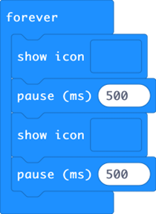

- Watch the following two videos of how to set up MakeCode coding guide and a demo of the working micro:bit: https://www.youtube.com/watch?v=2yzT7_QGLLc&t=8s (1:36 minutes)
and https://www.youtube.com/watch?v=8qzYWH10o6E (00:29 minutes)
- Set up your micro:bit to run with the program.
- Make the heartbeat faster or slower by changing the delay time.
- Animate other built-in images such as the small and large diamond or square.
- Create your own animations using your own designs.
- Challenge: Record the number of taps over 60 seconds for five trials.
- Before you start, predict how many movements of your finger or wrist are needed for specific actions per minute.
Answers will vary.
- To run each trial:
  - One group member uses the stopwatch to measure 60 seconds.
  - One group member taps their finger or wrist in time with the animation.
  - One group member counts the number of taps over 60 seconds. (For example, if the finger is moved 5 times to make the heart go faster, this is written down.)
  - One group member records the number of movements per minute at the end of the 60 seconds.
- Repeat the activity five times (trials) and record how many movements you make with your (a) finger and (b) wrist per minute for each change in animation in the tables below. (Note: you will complete 10 trials total, five for your finger and five for your wrist.)

Table 1: Qualitative data for the number of times per minute a finger was used for the beating heart micro:bit experiment Answers will vary.

Trial number | Beating heart fast | Beating heart slow | Small diamond | Small square | Large diamond | Large square | Student animation design #1 | Student animation design #2
1
2
3
4
5

Table 2: Qualitative data for the number of times per minute a wrist was used for the beating heart micro:bit experiment Answers will vary.

Trial number | Beating heart fast | Beating heart slow | Small diamond | Small square | Large diamond | Large square | Student animation design #1 | Student animation design #2
1
2
3
4
5

- List your observations.
Answers will vary.

- Draw an updated homunculus using the data you just collected.
Answers will vary. Have them draw a homunculus of what they perceive to be the brain areas responsible for the motions in their trials. Note: This can be a group activity, but students should have something like the diagram below.

https://commons.wikimedia.org/wiki/File:Anatomytool_Sensory_homunculus_English.jpg

