Google Colab Preparation Worksheet Answer Key
Objective: This worksheet aims to prepare you to effectively use Google Colab, a cloud-based platform for writing and executing Python code. The following questions and tasks will help you become familiar with the basic functionalities of Google Colab.

Question 1: Account Setup
Task: Create a Google account if you do not have one.

Question: Why is it necessary to have a Google account to use Google Colab?
Answer: A Google account is required because Google Colab is a service provided by Google, and it uses Google Drive for storing and managing notebooks.

Question 2: Accessing Google Colab
Task: Navigate to the Google Colab website by visiting Google Colab.

Question: What do you see on the Google Colab homepage, and what are the options for creating a new notebook?
Answer: On the Google Colab homepage, you should see options to create a new notebook, upload an existing notebook, view recent notebooks, and access example notebooks. To create a new notebook, you can click on "New Notebook."

Question 3: Basic Notebook Operations
Task: Create a new notebook and name it "My First Notebook."

Question: Describe the process of renaming a notebook in Google Colab.
Answer: To rename a notebook, click on the default name (usually "Untitled") at the top left of the notebook interface. This will allow you to type in a new name. Press Enter to save the new name.

Question 4: Running Code Cells
Task: In your new notebook, write and run a simple Python code that prints "Hello, Google Colab!"

Question: How do you execute a code cell in Google Colab, and what keyboard shortcut can you use to run the current cell?
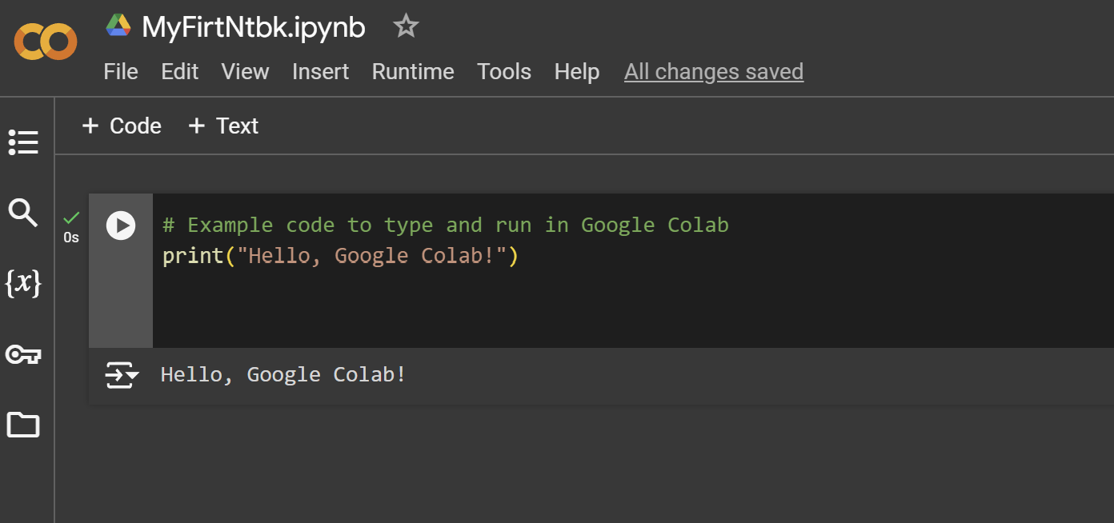
Answer: To execute a code cell, click the "Run" button on the left side of the cell or press Shift + Enter. This will execute the code in the current cell and move to the next cell.

Question 5: Using Markdown Cells
Task: Add a new text cell and use Markdown to create a heading that says "Introduction to Google Colab" and a bullet list with the items "Python Coding," "Data Analysis," and "Machine Learning."

Question: What is the purpose of Markdown cells in Google Colab, and how do you add a heading and a bullet list using Markdown?
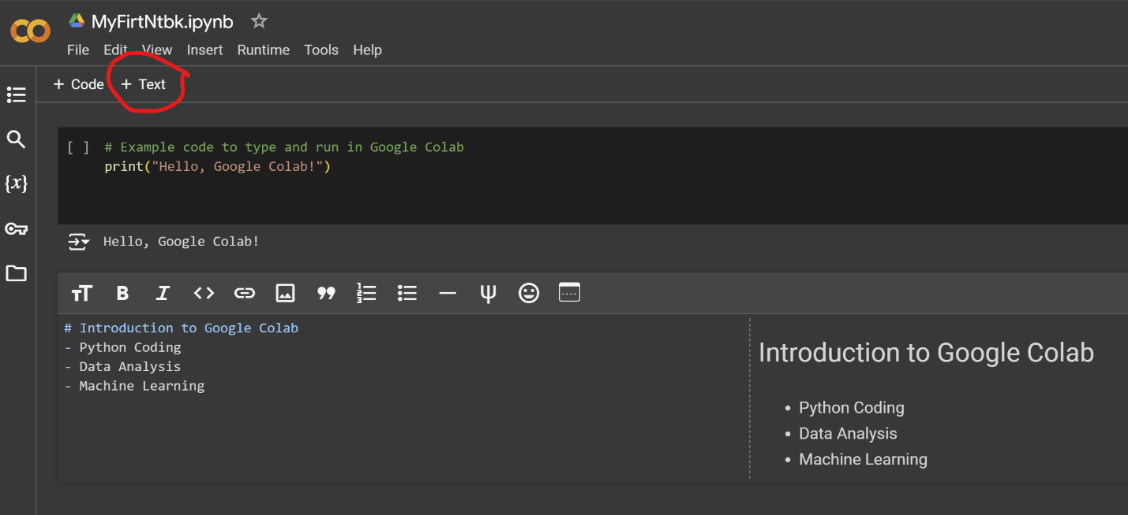
Answer: Markdown cells are used for adding formatted text, explanations, and documentation to your notebook. To add a heading, use the # symbol followed by a space (e.g., # Introduction to Google Colab). To create a bullet list, use - or * followed by a space (e.g., - Python Coding).

Question 6: Installing Python Libraries
Task: In a new code cell, install the pandas library using pip.

Question: What is the command to install the pandas library in Google Colab, and why might you need to install additional libraries?
Answer: The command to install the pandas library is !pip install pandas. Additional libraries might be needed to extend the functionality of your Python environment, allowing you to perform specific tasks such as data analysis, visualization, or machine learning.

Question 7: Verifying Library Installation
Task: Verify the installation of the pandas library by importing it and printing its version.
Question: Write the code to import pandas and print its version. What is the importance of verifying library installation?
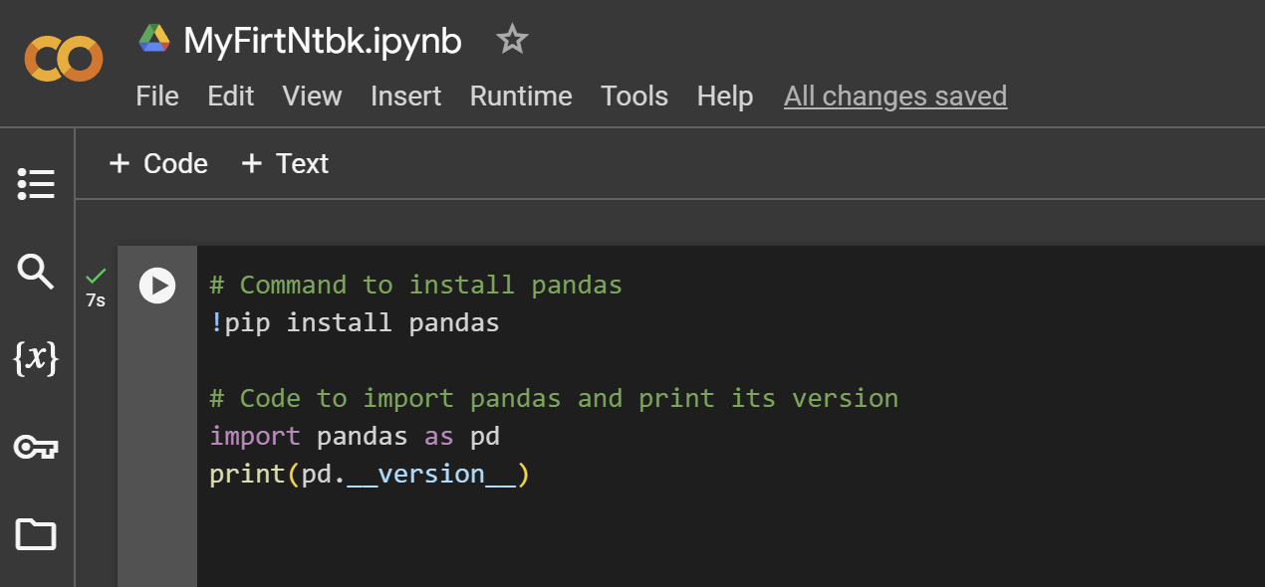
Answer: Verifying library installation ensures that the library is correctly installed and can be used without issues.
Question 8: Installing and Using Multiple Libraries
Task: Install matplotlib and scipy libraries, then create a simple plot using matplotlib.

Question: Write the commands to install matplotlib and scipy. Then, write a code snippet to create a simple plot using matplotlib.
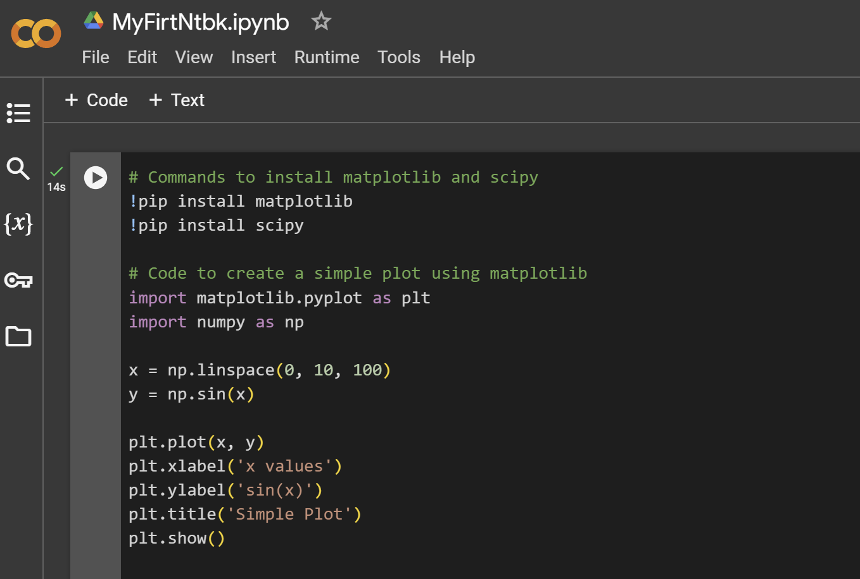
Answer: The commands to install the libraries are !pip install matplotlib and !pip install scipy. A simple plot can be created using matplotlib.

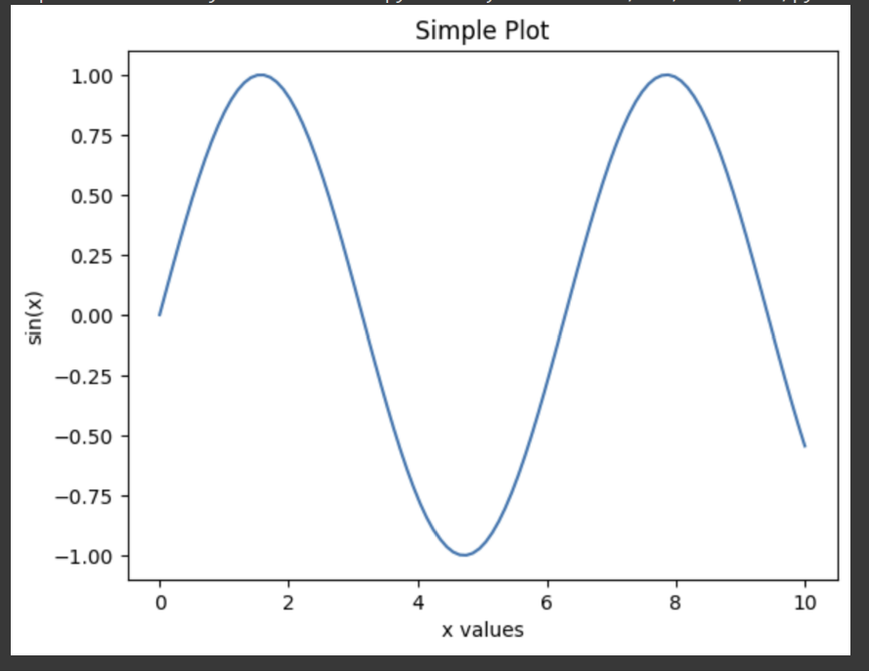

Completion: After answering these questions and completing the tasks, you should have a basic understanding of how to set up and use Google Colab, install necessary Python libraries, and run code cells.

Resources for Further Learning:
- Google Colab Welcome Page
- Google Colab Documentation
- Markdown Guide
- Pandas Documentation
- Matplotlib Documentation
- SciPy Documentation

Feel free to refer to these resources for additional information and advanced features of Google Colab.

