Name: Date: Class:

Post Assessment Answer Key

- Quiz on Learned Concepts
  - Neuroscience Applications:
    - Explain how electrical signals from muscles are recorded.
Electrical signals from muscles are recorded using electrodes that detect the electrical activity generated during muscle contraction, which is then amplified and recorded.

    - Describe how these signals can be analyzed to learn about the nervous system.
By analyzing the patterns and frequencies of muscle electrical signals, researchers can infer the functionality and health of the nervous system, including detecting abnormalities.

  - Data Conversion:
Outline the steps to convert a .wav file to a .csv file using Python.
Read the .wav file using a library such as SciPy, extract the waveform data, and write the data to a .csv file using Python's CSV module or Pandas.

  - Data Analysis and AI:
    - How can visualizing data help in understanding muscle activity?
Visualizing data helps identify patterns, trends, and anomalies, making it easier to interpret and understand muscle activity and its relationship with neural signals.

    - What are some basic machine learning techniques that could be applied to this data?
Techniques include supervised learning for classification and regression, clustering for pattern recognition, and feature extraction for dimensionality reduction.

- Hands-On Post-Test
  - Python Programming:
    - Write a Python script to convert a .wav file to a .csv file.
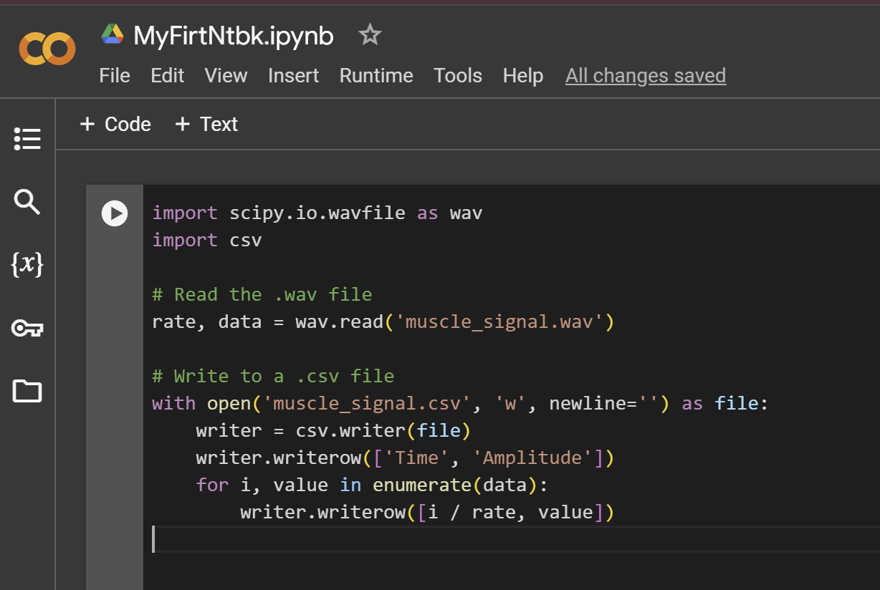
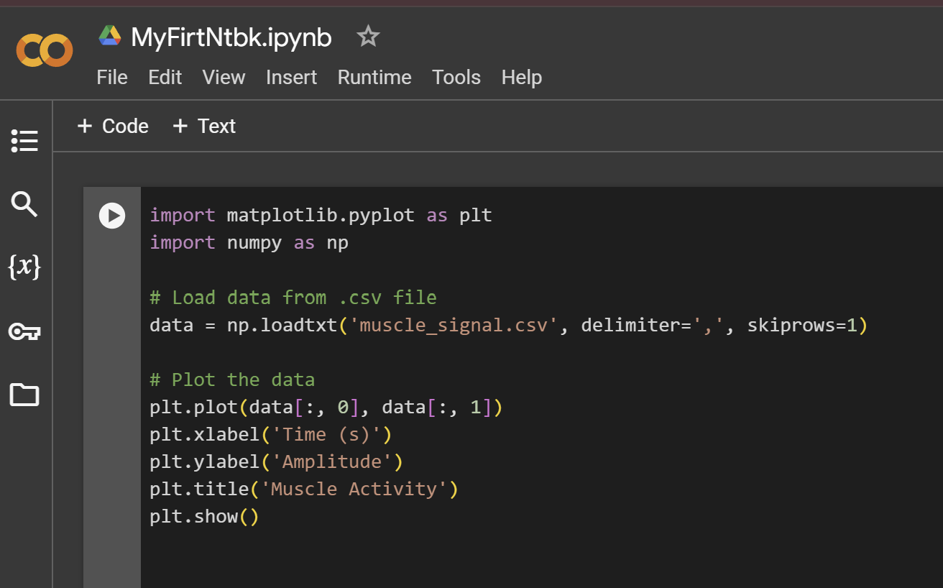
    - Create a simple plot of the muscle activity data using Matplotlib.
  - Collaborative Analysis:
    - In Google Colab, collaboratively analyze a dataset and summarize the findings.
Steps:
      - Import data into Google Colab.
      - Use Pandas to clean and analyze the data.
      - Use Matplotlib or Seaborn to visualize the data.
      - Summarize key findings in markdown cells within the notebook.

- Project-Based Assessment
  - Group Presentation:
    - Each group presents their findings, including data visualization and analysis.
    - Discuss the significance of your results in the context of neuroscience research.
Each group should prepare a presentation with slides showing data visualizations, analysis results, and key insights. They should explain how they converted the data, their analytical methods, and the significance of their findings.

  - Reflective Writing:
    - Write a short essay on what you learned about data conversion, analysis, and the application of AI in neuroscience.
Answers will vary. Students should write essays summarizing what they learned about data conversion, analysis, and the application of AI in neuroscience.

    - Reflect on the collaborative process and how it contributed to your understanding.
Answers will vary. Students should reflect on the collaborative process and how it contributed to their understanding, including any challenges faced and how they overcame them.

