**Name: Date: Class:**

### Pre-Assessment Answer Key

### Quiz on Basic Concepts

### Neuroscience Fundamentals

* + 1. What are neurons, and how do they communicate with muscles?

Neurons are nerve cells that transmit electrical signals. They communicate with muscles through synapses, where neurotransmitters are released, leading to muscle contraction.

* + 1. What is electrophysiology?

Electrophysiology is the study of the electrical properties of biological cells and tissues, including the recording of electrical activity from muscles and nerves.

1. **Programming Basics**:
   1. What is Python, and what are its common uses?

Python is a high-level programming language used for web development, data analysis, scientific computing, artificial intelligence, and more.

* 1. Can you write a simple Python script to read a file?  
     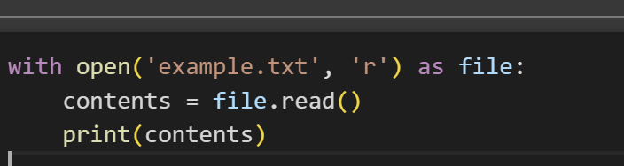
  2. Data Science Basics:
     1. What is a .wav file?

A .wav file is an audio file format that stores waveform data.

* + 1. What is a .csv file?

A comma-separated value (.csv) file is a plain text file that stores tabular data in rows and columns, with each value separated by a comma.

### Hands-On Pre-Test

* 1. Python Programming:
     1. Write a simple Python script to print "Hello, World!"  
        **print("Hello, World!")**
     2. Read a text file and print its contents.  
        
  2. Using Google Colab:
     1. Open a Google Colab notebook and execute a basic Python cell.

Steps: Go to Google Colab, create a new notebook, and enter the following code in a cell: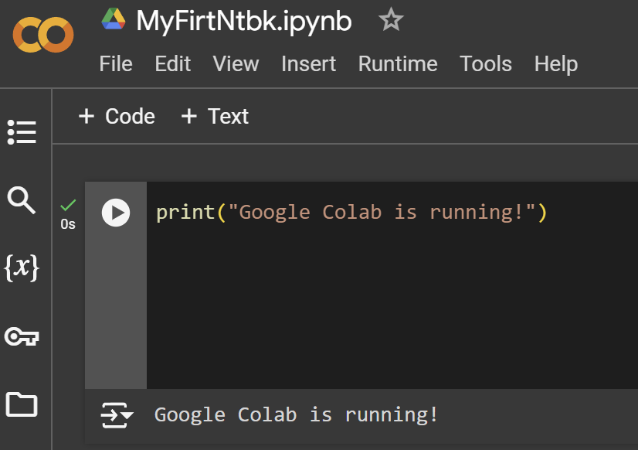

* + 1. Install a Python library (e.g., NumPy) in Google Colab.

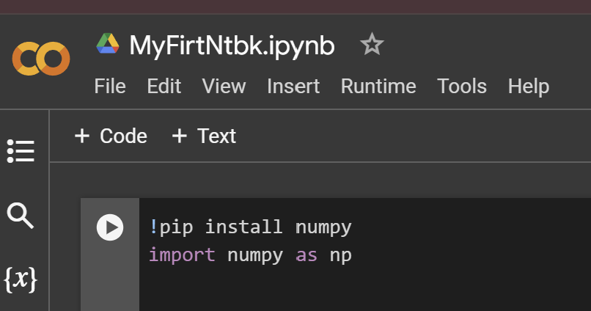Enter the following code in a cell and execute:

1. **Group Discussion**
   1. Discuss what you know about recording and analyzing electrical signals from muscles.

Students should mention the basics of using the Muscle SpikerBox kits from their previous activity.

* 1. Brainstorm how you think data conversion from .wav to .csv might be done.

Students should hypothesize on the process of converting .wav files to .csv files, such as extracting numerical data from audio signals.