**Day 2 Handout: Getting Familiar With Micro:bit Answer Key**

**Introduction:**

A micro:bit is a small programmable device that allows students to learn computer programming and coding. The image below shows the various parts of a micro:bit.

**DO NOW:** In your group, look at your micro:bit and, using the image below, identify all the parts in your micro:bit shown there.

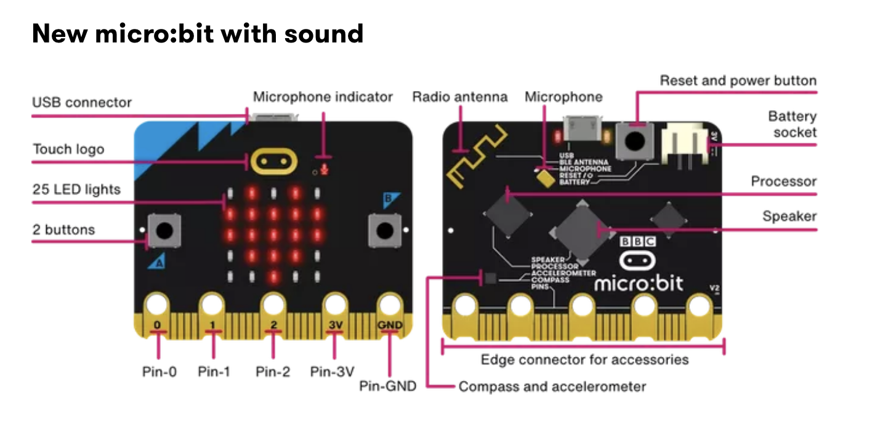

[https://microbit.org/get-started/features/overview](https://microbit.org/get-started/features/overview/)

Image 3: Parts of the micro:bit

**Video 1**

1. Watch the tutorial “Micro:bit: Flashing Heart Tutorial” at <https://www.youtube.com/watch?v=hiERNxxfxJQ>.
2. After watching this tutorial, create your own flashing hearts. You must complete this before moving to the next step.

Visit every group to make sure there is a flashing heart on their micro:bit. You can let each group know that they can go on to the next video.

image taken from video tutorial 1

**Video 2**

1. Watch the first 2 minutes of the video “Science Experiment 05 EMG Sensor” at <https://www.youtube.com/watch?v=vxlPQZIwYRc>.
2. In your own words, explain how sensory and motor nerves work and how they communicate information through electrical impulses. Be ready to share your ideas with the class.

### **Sensory Nerves:**

Sensory nerves are responsible for carrying information from the body's sensory receptors (like those in the skin, eyes, ears, and other organs) to the brain and spinal cord. These nerves detect changes in the environment, such as temperature, pressure, light, or sound, and convert this information into electrical signals, known as nerve impulses. Once these impulses reach the brain, they are processed, allowing us to perceive sensations such as pain, heat, or the texture of an object.

### **Motor Nerves:**

Motor nerves work in the opposite direction. They carry instructions from the brain and spinal cord to the muscles and glands in the body. When the brain decides to move a muscle, it sends an electrical impulse through motor nerves to the appropriate muscle fibers, causing them to contract and produce movement. These nerves also control involuntary actions, like the beating of your heart or the movement of food through your digestive system.

### **Communication through Electrical Impulses:**

Both sensory and motor nerves communicate through electrical impulses, which are rapid changes in voltage across the nerve cell's membrane. These impulses travel along the nerve cells (neurons) as a wave of electrical activity, called an action potential. When the action potential reaches the end of a nerve cell, it triggers the release of neurotransmitters, which are chemicals that pass the signal to the next neuron or directly to the target muscle or organ.

**Practice Creating EMG Sensors**

Make sure your group has the following materials:

* 1 micro:bit and laptop/computer
* MakeCode open on your computer
* 3 electrodes
* 1 muscle sensor
* 1 pair of scissors
* 3 connecting wires for the micro:bit
* 2 alligator clips

#### 

#### **Procedure**

Place a checkmark next to each step that you complete.

#### **Program the Micro:bit:**

* Open the MakeCode editor.
* Create a new project called “Muscle Sensor.”
* Write a simple program that reads the analog input from the EMG sensor (the electrode connected to the analog pin).
* Display the readings on the micro’s LED matrix, or send them over to a connected computer via USB for further analysis.
* Drag serial write value under forever. Type: “EMG_Sensor”.

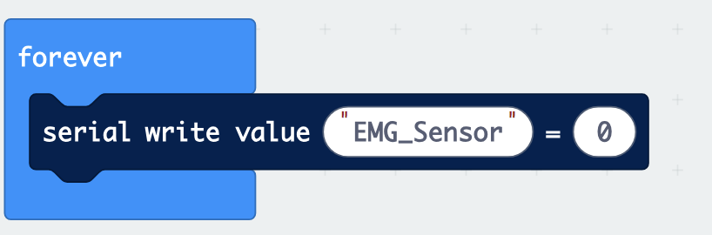

Image 4: Computer code for Serial Value

* Click on Pins and then on an analog read pin.

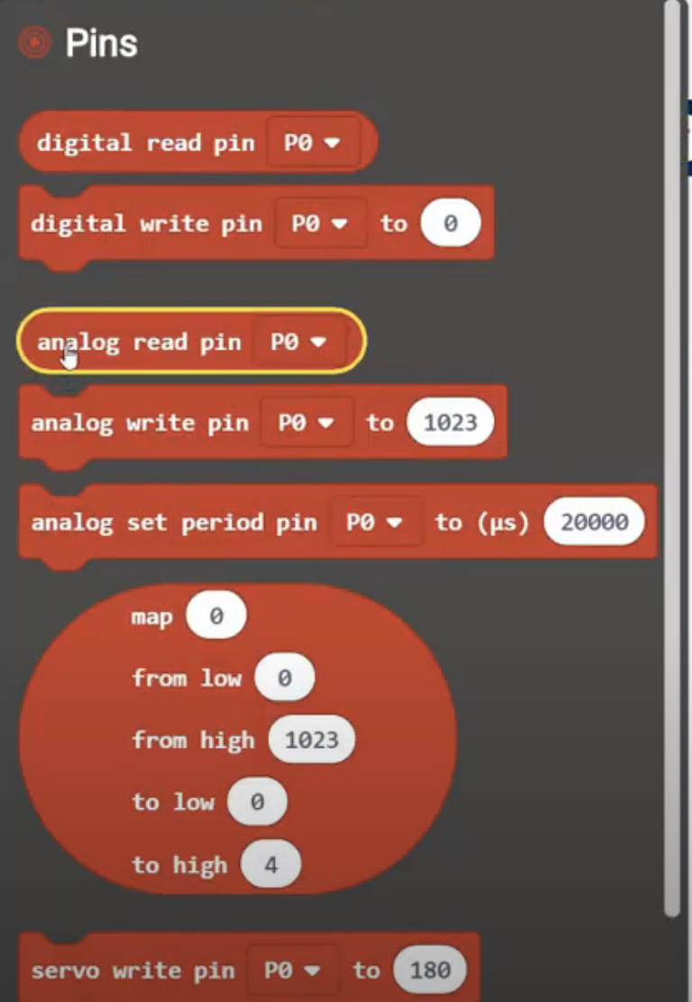

Image 5: Sample computer code for analog read pin

* Drag it and place it over =0. Click on pin and change it to P2.

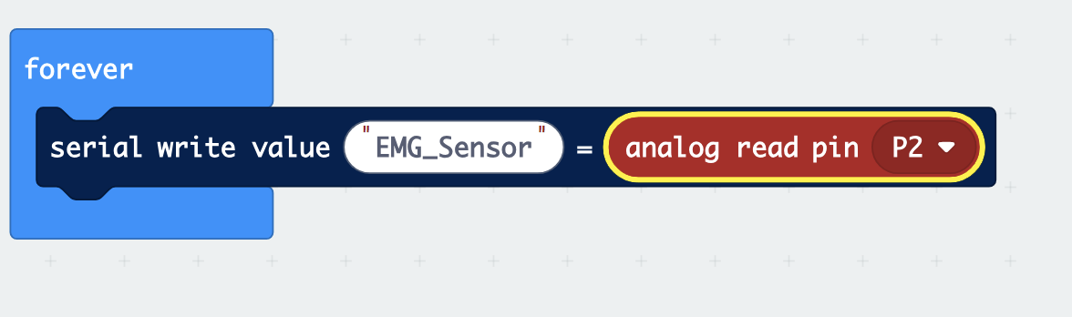

Image 6: Complete code for micro:bit

* Connect your micro:bit and download the code to your micro:bit.

1. **Create the Electrodes:**

* Place three electrodes in the muscle sensor.
* These electrodes will pick up the electrical signals generated by muscle activity.

1. **Connect the Muscle Sensor to Micro:bit:**

* Connect the alligator clips to the micro:bit following the chart below.

|  |  |
| --- | --- |
| **Muscle Sensor** | **Micro:bit** |
| VIN wire | 3V power pin |
| GND wire | GND |
| ENV wire | Pin 2 (P2) |

Image 7: Chart created by Hend Rasheed

#### **Attach Electrodes to the Skin:**

* Place electrodes right under the wrist in your right hand. Refer to the picture below.

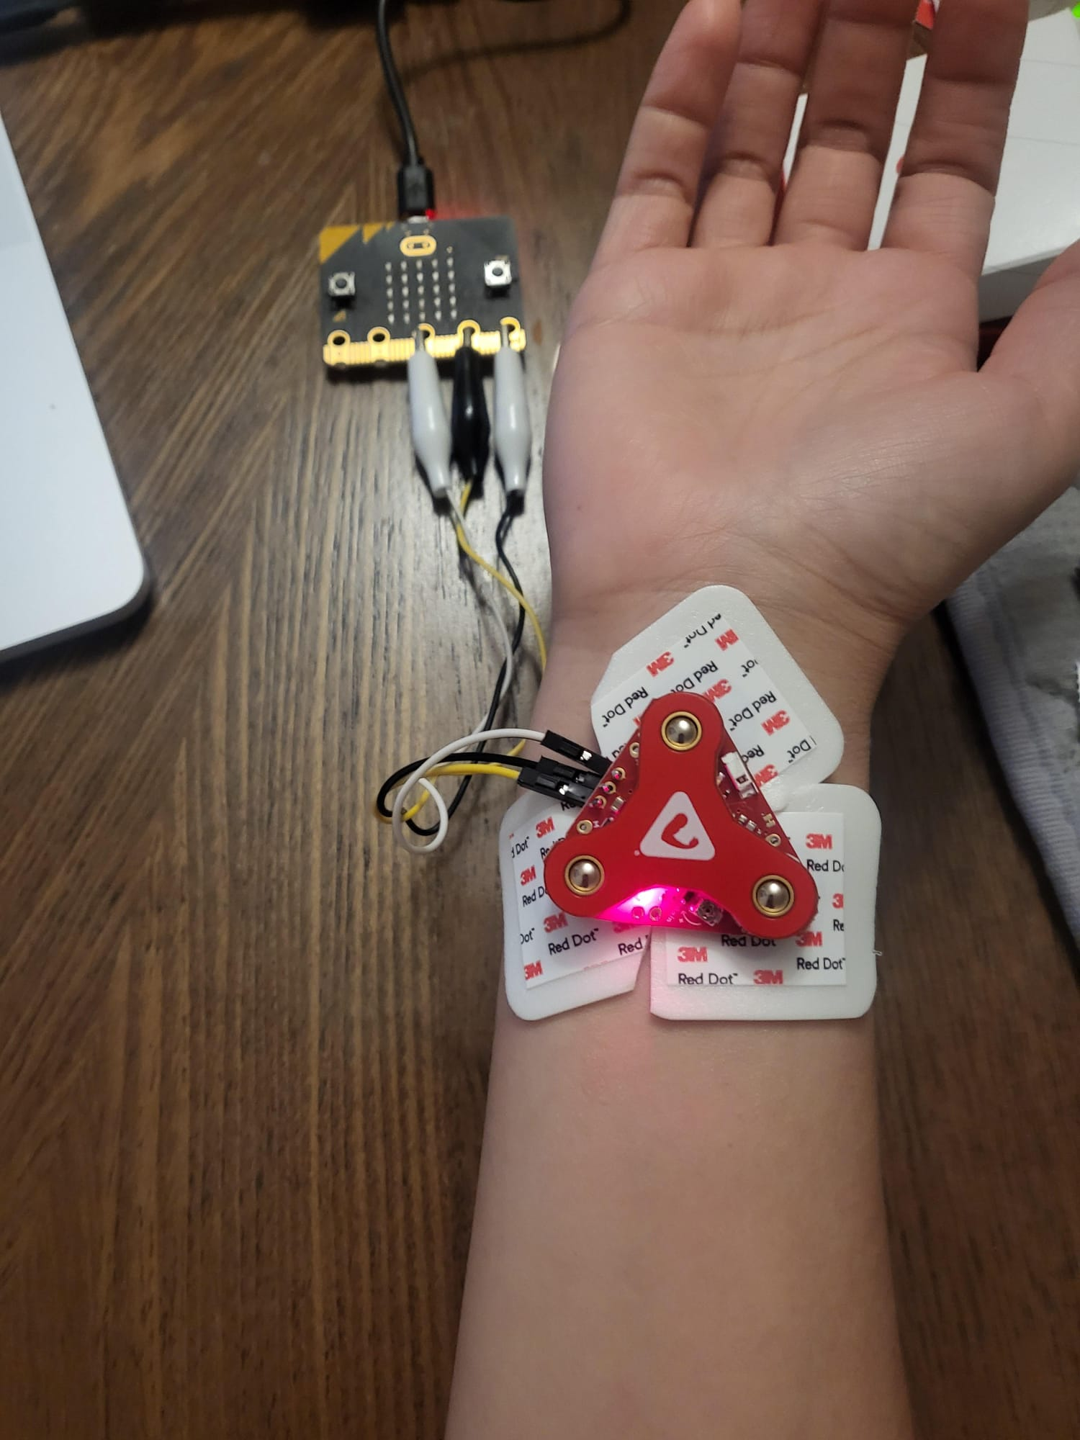

Image 8: Sample experiment setup

* Click on show data and record.

1. **Test Setup:**

* Flex your muscle and observe the changes in the readings on the micro:bit. When you contract the muscle under the electrodes, the readings should increase, indicating the detection of muscle activity.
* Move your wrist side to side, up, and down. Open and close hand.
* What do you notice? What movements did you do? What does this data suggest?

Answers will vary.

1. **Data Collection and Analysis**

Let’s look at each individual hand movement and the data it provides. Select three different movements. For each movement, provide a screenshot of the EMG signal data. Under each screenshot, describe it using the numerical data provided. (Note: Keep an eye on the minimum and maximum numbers you see.)

|  |
| --- |
| Movement 1: |
| Graph (screenshot) |
| Numerical data observations |

|  |
| --- |
| Movement 2: |
| Graph (screenshot) |
| Numerical data observations |

|  |
| --- |
| Movement 3: |
| Graph (screenshot) |
| Numerical data observations |

1. **Screenshots/Conclusion:** Take a couple of screenshots of your data and write a conclusion paragraph in the MEAL format (main idea, evidence, analysis, and link to real world). Note that your evidence must be taken from the EMG signals collected using the micro:bit.

Answers will vary.

1. **Self-Assessment:** Write about the parts of this activity that were most difficult for you, and why. Then write about what parts were easier for you, and why.

Answers here may vary. Main idea should include information about muscle movement and EMG sensors. Evidence should be in the form of graphs that were recorded using micro:bits. Under the graph, students should provide a short explanation of what they see and understand from the graph. For example, students should make reference to numerical values at each pick and lower part of the graph. Last, students can investigate applications about these EMG sensors in sports or maybe treatments/diagnosis of diseases.