**Day 2 Handout: Getting Familiar With Micro:bit**

**Introduction:**

A micro:bit is a small programmable device that allows students to learn computer programming and coding. The image below shows the various parts of a micro:bit.

**DO NOW:** In your group, look at your micro:bit and, using the image below, identify all the parts in your micro:bit shown there.

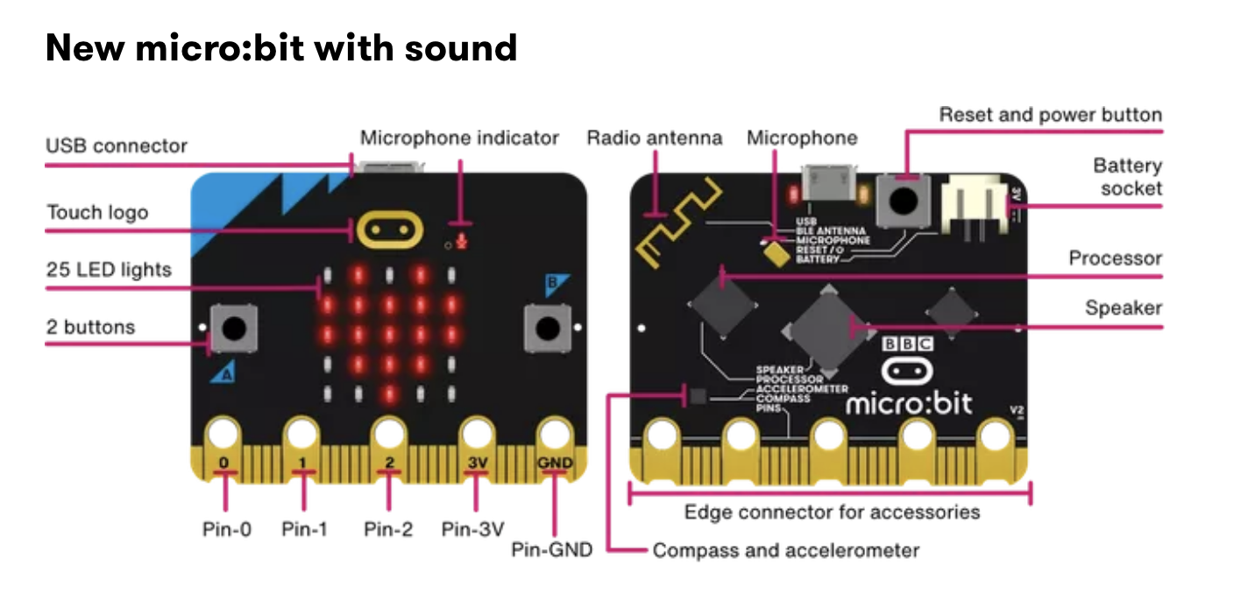

[https://microbit.org/get-started/features/overview](https://microbit.org/get-started/features/overview/)

Image 3: Parts of the micro:bit

**Video 1**

1. Watch the tutorial “Micro:bit: Flashing Heart Tutorial” at <https://www.youtube.com/watch?v=hiERNxxfxJQ>.
2. After watching this tutorial, create your own flashing hearts. You must complete this before moving to the next step.

**Video 2**

1. Watch the first 2 minutes of the video “Science Experiment 05 EMG Sensor” at <https://www.youtube.com/watch?v=vxlPQZIwYRc>.
2. In your own words, explain how sensory and motor nerves work and how they communicate information through electrical impulses. Be ready to share your ideas with the class.

**Practice Creating EMG Sensors**

Make sure your group has the following materials:

* 1 micro:bit and laptop/computer
* MakeCode open on your computer
* 3 electrodes
* 1 muscle sensor
* 1 pair of scissors
* 3 connecting wires for the micro:bit
* 2 alligator clips

#### **Procedure**

Place a checkmark next to each step that you complete.

#### **Program the Micro:bit:**

* Open the MakeCode editor.
* Create a new project called “Muscle Sensor.”
* Write a simple program that reads the analog input from the EMG sensor (the electrode connected to the analog pin).
* Display the readings on the micro’s LED matrix, or send them over to a connected computer via USB for further analysis.
* Drag serial write value under forever. Type: “EMG_Sensor”.

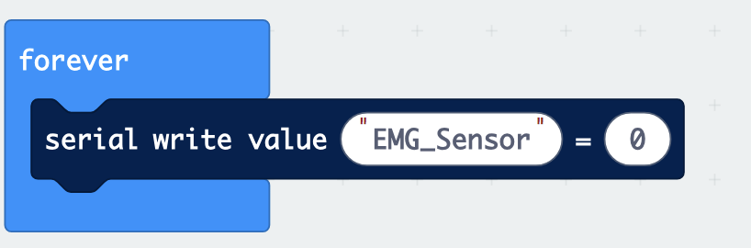

Image 4: Computer code for Serial Value

* Click on Pins and then on an analog read pin.

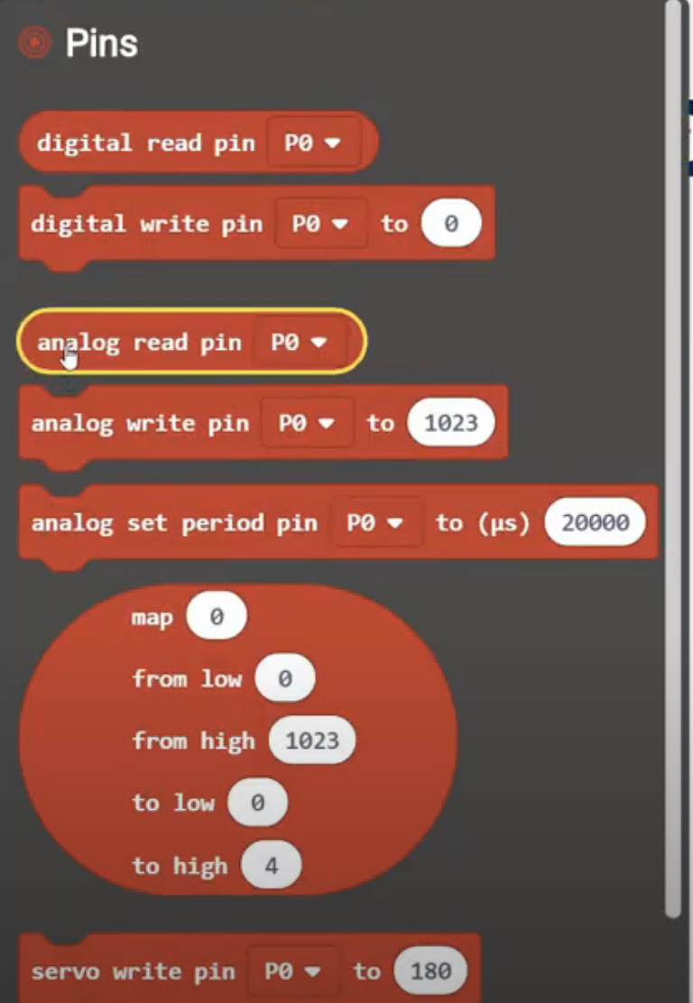

Image 5: Sample computer code for analog read pin

* Drag it and place it over =0. Click on pin and change it to P2.

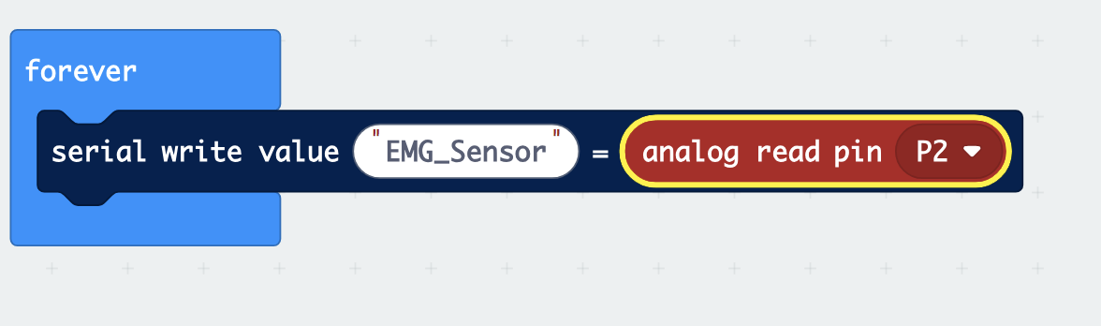

Image 6: Complete code for micro:bit

* Connect your micro:bit and download the code to your micro:bit.

1. **Create the Electrodes:**

* Place three electrodes in the muscle sensor.
* These electrodes will pick up the electrical signals generated by muscle activity.

1. **Connect the Muscle Sensor to Micro:bit:**

* Connect the alligator clips to the micro:bit following the chart below.

|  |  |
| --- | --- |
| **Muscle Sensor** | **Micro:bit** |
| VIN wire | 3V power pin |
| GND wire | GND |
| ENV wire | Pin 2 (P2) |

Image 7: Chart created by Hend Rasheed

#### **Attach Electrodes to the Skin:**

* Place electrodes right under the wrist in your right hand. Refer to the picture below.

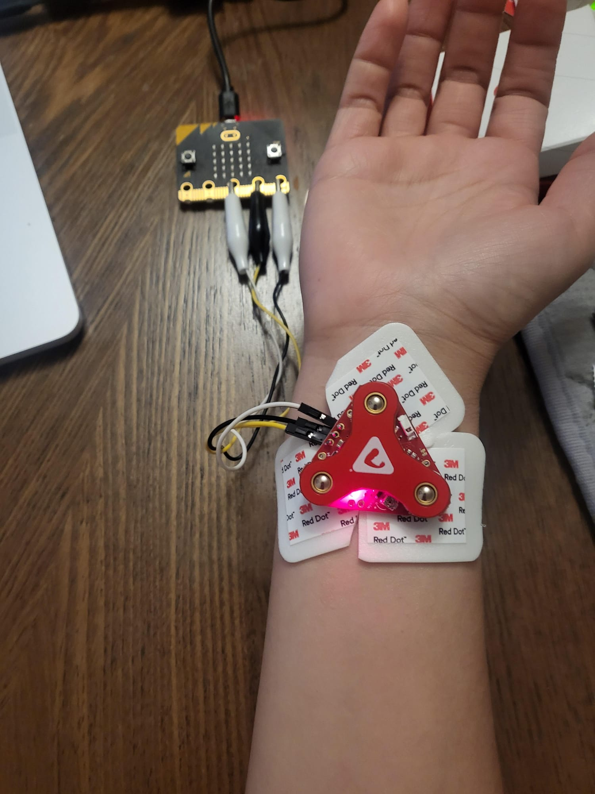

Image 8: Sample experiment setup

* Click on show data and record.

1. **Test Setup:**

* Flex your muscle and observe the changes in the readings on the micro:bit. When you contract the muscle under the electrodes, the readings should increase, indicating the detection of muscle activity.
* Move your wrist side to side, up, and down. Open and close hand.
* What do you notice? What movements did you do? What does this data suggest?

1. **Data Collection and Analysis:**

Let’s look at each individual hand movement and the data it provides. Select three different movements. For each movement, provide a screenshot of the EMG signal data. Under each screenshot, describe it using the numerical data provided. (Note: Keep an eye on the minimum and maximum numbers you see.)

|  |
| --- |
| Movement 1: |
| Graph (screenshot) |
| Numerical data observations |

|  |
| --- |
| Movement 2: |
| Graph (screenshot) |
| Numerical data observations |

|  |
| --- |
| Movement 3: |
| Graph (screenshot) |
| Numerical data observations |

1. **Screenshots/Conclusion:** Take a couple of screenshots of your data and write a conclusion paragraph in the MEAL format (main idea, evidence, analysis, and link to real world). Note that your evidence must be taken from the EMG signals collected using the micro:bit.
2. **Self-Assessment:** Write about the parts of this activity that were most difficult for you, and why. Then write about what parts were easier for you, and why.