**NeuroMaze Guide**

**Guiding Questions:**

* What is the ultimate goal of your robot?
* What constitutes successful maze navigation?
* What constraints must you work within?
* How do different maze-solving algorithms work?
* What sensors are available on your Cutebot?
* What are the key challenges in maze navigation?

**Design Considerations:**

* How does the engineering design process guide your work? Include descriptions for each step of the process.

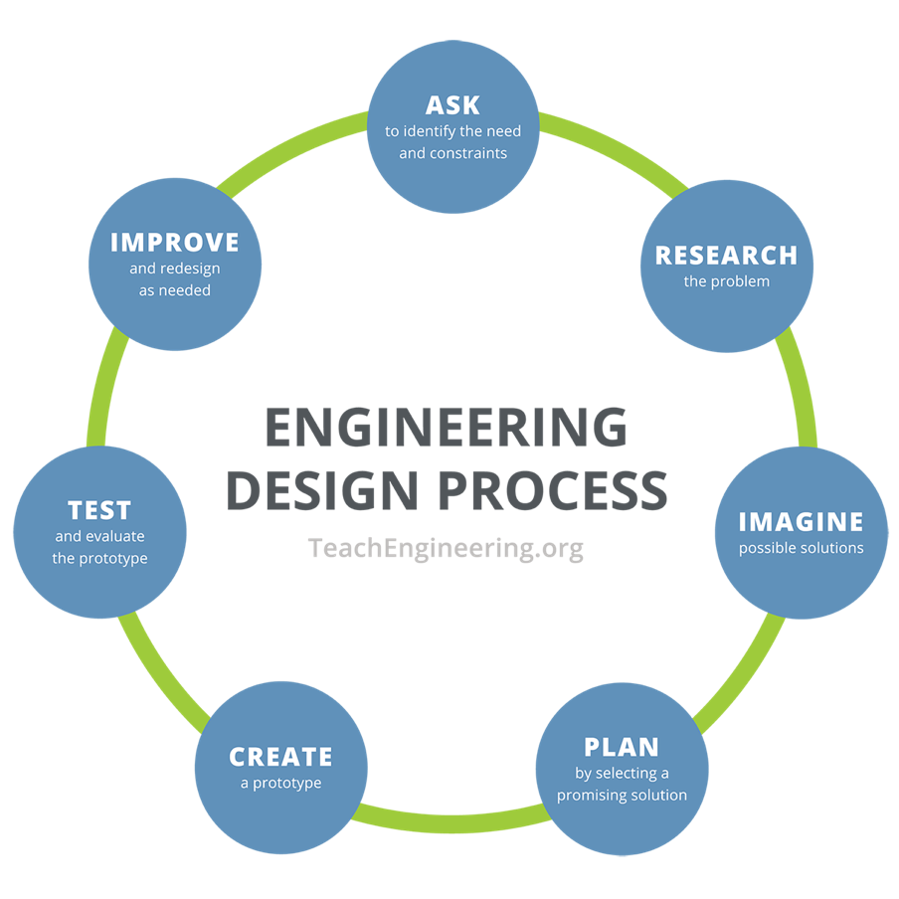

* How will the robot detect walls?
* When should it turn vs. go straight?
* How will it recognize the finish line?
* What speeds work best for different actions?

**Data Table**

|  |  |  |  |
| --- | --- | --- | --- |
| **Trial** | **Successful** | **Issues Observed** | **Modifications Made** |
|  |  |  |  |
|  |  |  |  |
|  |  |  |  |
|  |  |  |  |
|  |  |  |  |

**Design Checklist**

* Flowchart completed
* Basic movement code written
* Sensor integration completed
* Navigation logic implemented
* Testing data collected
* Optimization performed
* Documentation finished
* Reflection questions answered