**Post Assessment Day 1**

**THE BRAIN IS A COMPUTER?**

1. Sketch a human brain and label the four lobes.

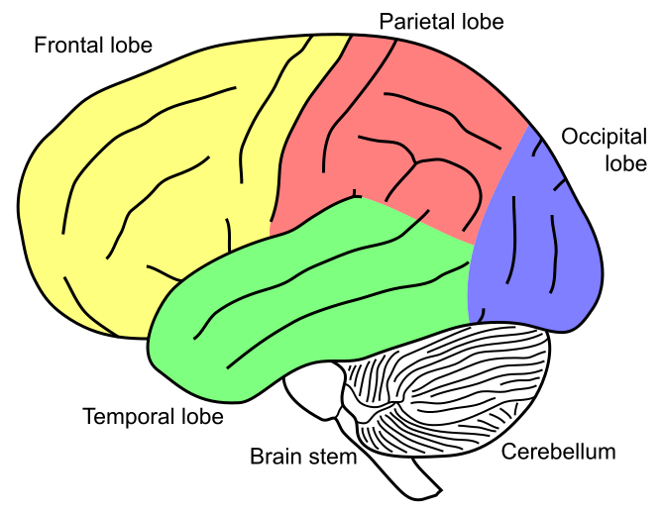

1. EXTENSION:

For the five parts of the brain in Slides 18 and 19, are there areas that overlap? If you had to represent the brain and the nervous system, what type of circuit would you use to describe it? Explain.

**Frontal Lobe/Cerebellum (Movement)**

**Frontal Lobe/Temporal Lobe (Emotion)**