How Do Our Ears Work? Quiz Answers
- How do humans hear sounds?
Humans hear sounds using our ears, which have an interesting set of bones and a fluid-filled structure, to determine sound types.

- How does human hearing work? Sketch and label the system.
Sound waves enter through the outer ear, are amplified by the middle ear, and are converted into electrical impulses within the inner ear.
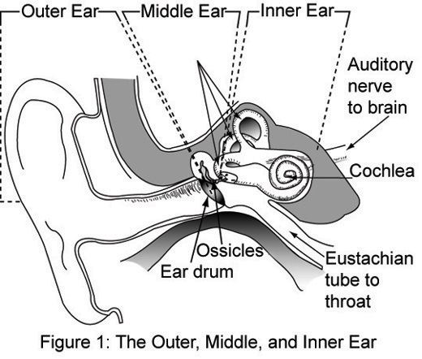
Any student drawings that are similar to the sketch below are acceptable.

Image source: NASA via Wikimedia Commons http://commons.wikimedia.org/wiki/File:Outer,_middle_and_inner_ear.jpg
- Do you know of any sensor that detects sound and how it might do it? Explain.
A microphone is an example of a sensor that detects sound. It detects voices and instruments and converts them into electricity, which is sent to speakers that convert it back into sound.

