Sound Post-Quiz Answer Key
- What is sound?
Sound is created by the vibration of air particles.

- What is the difference between a loud sound and a soft sound in terms of pitch?
They differ primarily in amplitude and not pitch (frequency).

- Draw sound waves for high-pitch and low-pitch sounds.
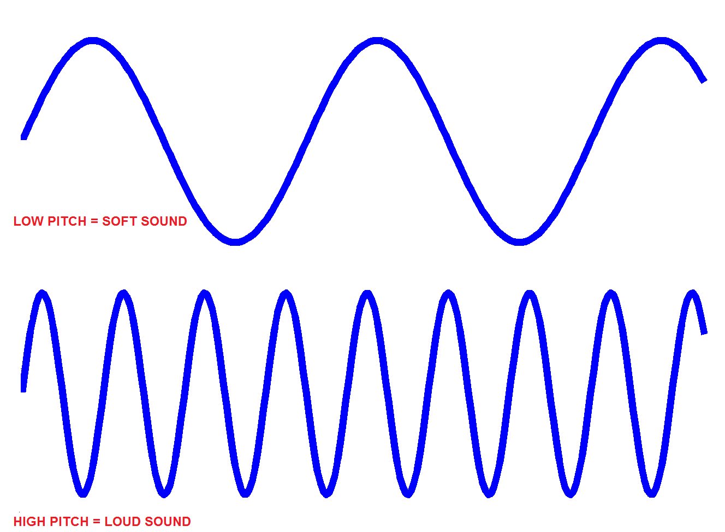
A high-pitch sound has more waves per unit time, compared to a low-pitch sound.

low-pitch

high-pitch

- When you hum the same note continuously, does it produce a distinguishable waveform?
How about when you scream?
A note usually is close to a “sine” in form, while a scream has lots of frequencies.

