Sound Worksheet Answer Key
- What were your observations when you generated sounds with 50, 100, 200, 500, 800, 1000, 10000 Hz frequencies and played them?
As we move from 50 to 500 Hz, we see that more and more waveform cycles get accommodated in a given time frame, that is, for 50H z there was only one waveform cycle and for 500 Hz it had 10 cycles.
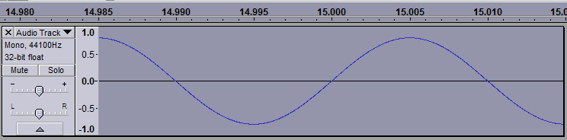
50 Hz

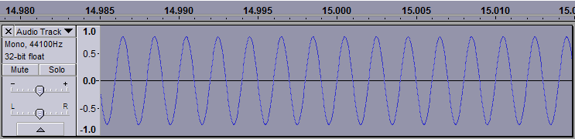
500 Hz

- How do “tone” and “noise” differ in their waveforms and how they sound?
Noise is a mixture of different frequencies with variable amplitude. It looks very different from the tone signal.
Tone:

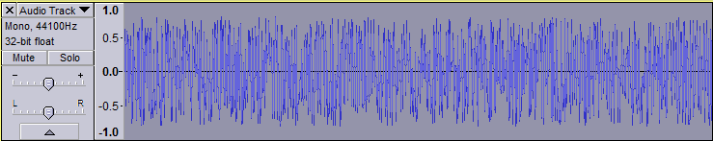
Noise:

- Tap in/on the desk below the computer and see what sound is captured by the microphone.
What do you observe?
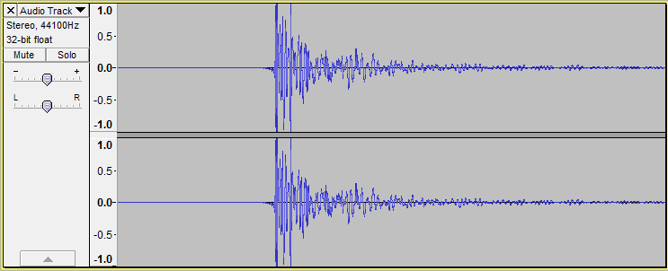
The screen capture below shows the recording when the desk is tapped to record sound. This waveform resembles the noise waveform more than the tone waveform. The reason for this is that the noise from the desk is not of one frequency but a combination of different ones.

- Try singing the solfege notes (do-re-mi-sol-la-ti) one at a time, for 5 seconds each.
What do you observe?
The number of cycles increases as we go from “do” to “ti.” It is similar to the increasing tone experiment.

- Try speaking the same word (such as “hello”) in three different tones (whisper, normal and loud).
What are the main differences between the waveforms?
The loudness of the sound comes from its amplitude. For “whisper,” we have the shortest amplitude and for “loud,” we have the highest amplitude.

