Loops and Switches Quiz
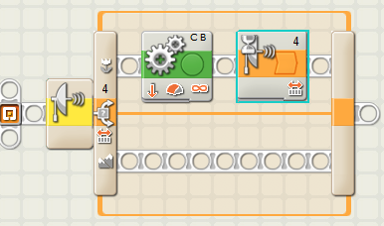
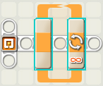
- What kind of blocks are these?

- Name two kinds of controls can be specified to determine how long a loop repeats.

- Give an example of a program you could write that would use a switch.

