Worksheet Answers
- Make a sketch of the human brain and label the four lobes.
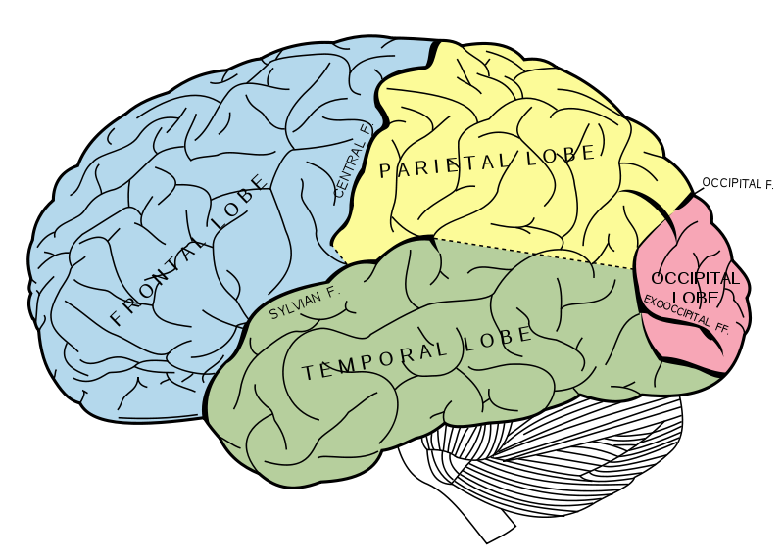
Lobes: frontal, parietal, temporal, occipital

Image source: 2006 Mysid, Wikimedia Commons http://commons.wikimedia.org/wiki/File:Gray728.svg
(Principal fissures and lobes of the cerebrum viewed laterally. Figure 728 from Gray's Anatomy.)

- How much does an adult brain weigh?
The adult human brain weighs on average about 3 lbs. (1.5 kg).

