Alkane Resources Activity Project Notebook

Assign Roles for Team Partners:

Captain: ______________________________________________
Captain reports any information to the teacher and keeps the team moving at the assigned pace.

Recorder: _____________________________________________
Recorder writes responses to all team activities once the team agrees on their responses.

Technologist: ____________________________________________
Technologist opens assigned web pages on their own device and makes sure everyone can see and interact with the web pages together.

Day 1: Problem-Finding
Consider your own background experience to answer these two questions:
What problems can we solve by using renewable resources?

Can most cars currently use renewable fuel? Why or why not?

Use the presentation slides and this video from CISTAR to answer these questions:
How much oil is used for transportation each day in the USA?

What percent of transportation fuel currently comes from oil?

What percent of chemicals, including plastics, comes from oil?

What percent of transportation fuel and chemicals do we want to replace with renewable sources?

How long will it take to develop the technology to completely convert to renewable fuels?

What resource found in the USA can replace imported oil?

How long is that resource projected to last?

Which light hydrocarbons are found in shale gas? Write their chemical formulas here.

What two main products are obtained by processing shale gas?

Which reaction will we be looking at during this project?

Evaluate your own current understanding of the problem: Light shale gases like ethane need to be converted into fuels and petrochemicals. How can that be done?
What do you KNOW about this problem?

What do you NEED TO KNOW about this problem?

Project Vocabulary: Discuss with your team the main differences, if any, between the meanings for these words that you wrote on your pre-assessment and their actual definition provided in the Project Glossary above. Then score each word from 1-3 for level of understanding.

1 – No understanding of this word
2 – Some understanding of this word
3 – Complete understanding of this word

Level of Understanding
element
compound
chemical reaction
hydrocarbon
alkane
monomer
oligomerization
renewable resource
nonrenewable resource

Alkanes
Alkanes are compounds that contain only carbon and hydrogen atoms, so they are in a larger class of chemical compounds called hydrocarbons. Alkanes only have single bonds between carbon atoms. Other types of hydrocarbons may also contain double or triple bonds between carbon atoms. The bonds between carbon and hydrogen are always single bonds.

Day 2: Investigating Hydrocarbons
Each group has been assigned an alkane compound to investigate using WebMO.

Name of your alkane: ___________________________________________

Chemical formula of your alkane: _________________________________________

How many carbon atoms are in your alkane? _______________________________________

How many hydrogen atoms are in your alkane? ____________________________________

Create a model of your alkane using WebMO.
  - Go to WebMO Demo Server: https://www.webmo.net/demoserver/cgi-bin/webmo/login.cgi

  - Log in with these credentials:
    - Username: guest
    - Password: guest

  - Type <enter>

  - Across the top should read “New Job”, “Refresh”, “Download”, etc.

  - Select “New Job”.

  - Click “Create New Job”. This will go to the “Build Molecule” page.

  - Click the blank screen once for each carbon atom in the molecule.

  - Move the cursor between clicks so the carbon atoms are in a line.

Image(s) created with WebMO software, www.webmo.net

  - Draw a chemical bond between each of the atoms: Click and hold the cursor on the first atom and drag the cursor to the next atom. Control-Z will reverse any mistakes.
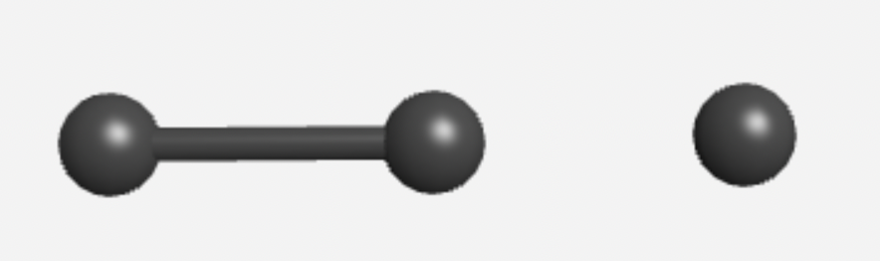
Image(s) created with WebMO software, www.webmo.net

  - Select “Build”, then select H for hydrogens.

  - Click the blank screen once for each hydrogen atom, spreading them evenly around the carbon atoms.

  - Draw a chemical bond between each hydrogen and the nearest carbon atom.

  - Under “Cleanup”, select “Geometry” to correct the shape of your molecule.
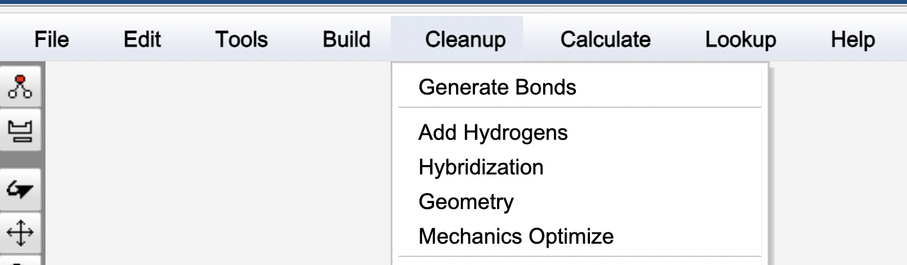

  - Under “Lookup”, select “Molecule Info” and record the following information about your molecule:

Stoichiometry:

IUPAC Name:

Molar Mass:

Day 3: Problem-Solving
      - From your experience using WebMO, brainstorm for ideas to convert ethane into larger molecules. Write at least two ideas here.

- Find the definition for oligomerization in the Project Glossary in the Introduction slides. Do your best to write that definition in your own words here:

Let’s think about how oligomerization could be used to make butylene C₄H₈ from ethylene, C₂H₄.

- Get a set of gumdrops and toothpicks. Decide as a group which colors represent carbon and hydrogen atoms.

- Fill in the table with the number of carbon and hydrogen atoms for both ethylene and butylene.

C₂H₄  Note: ethylene has a double bond between the carbon atoms |  | C₄H₈  Note: butylene has a double bond between the first two carbon atoms
carbons | hydrogens | carbons | hydrogens

- Use the gumdrops to model ethylene and butylene molecules.

- Use the extra gumdrops to model how ethane can be converted into octane.

- Set up the models with an arrow from the starting products to the ending products. When complete, check your reaction model using the rubric below.

[Reactants] --> [Products]

Gumdrop Reaction Rubric | No  (0 points) | Sort of  (1 point) | Yes  (2 points)
The reactants are clearly on the left side of the arrow and the products are clearly on the right.
Ethylene and butylene molecules are depicted with one double bond (two toothpicks between atoms)
The reactants contain one or more ethylene molecules, and the products contain one or more butylene molecules
Both sides of the reaction have the same number of hydrogen atoms
Both sides of the reaction have the same number of carbon atoms

Total Score: ___________

- Correct your reaction model until it has a score of at least 8 points before your captain asks me to come check it.

- Take a photo of your model reaction and add it here if using this worksheet digitally.

