Testing Your Knowledge and Going Beyond Answers

More ideas to think about.
- What does LED stand for?
Light Emitting Diode.

- What does a diode do?
Allows electricity to travel in one direction only.

- Which side of the LED goes with the positive side of the battery?
The long wire connects to the positive side of the battery.

- Draw the card circuit using electronic symbols for the parts.
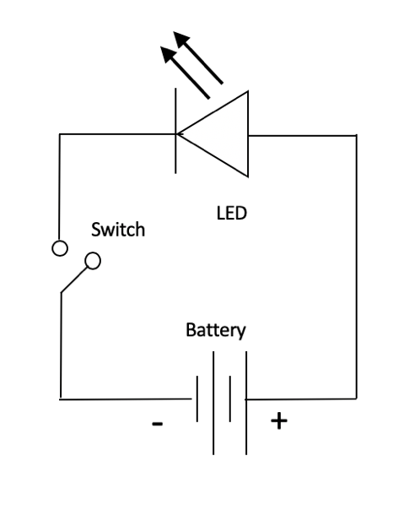
- How did the Card Company line up the two copper tape lines correctly?
It used “registration marks” – a hole and a pen mark – to place the LED and position the copper tapes.

- What properties of the materials kept the battery from always being on?
The stiffness of the cardstock prevents the front cover of the card from lying flat on the battery inside. In essence, it made a switch.

- Can you think of another way to make a switch for your card? Describe it.
Some examples: A switch could be made exploiting the stiffness of the LED wire. A pocket could be made for the battery (see for example: https://chibitronics.com/paper-battery-holder-tutorial/ or https://chibitronics.com/how-to-create-a-paper-battery-holder-with-foam-adhesives/). A lever made of paper or cardboard could be rotated over the battery.

- Can you foresee any problems with using the carbon paint?
The carbon paint cracks and chips off, which lowers conductivity or, if severe enough, breaks the conduction all together. The carbon paint is also water soluble so it could wash off if dampened.

- Do you think the thickness and dimensions of the carbon paint are important in determining how well it conducts? Yes.

- How would you design an experiment to test the conductivity of the carbon paint as a function of the line dimensions?
Make lines of different dimensions and measure their resistance. To do it systematically, make stencils (then lines) of dimensions a x b, 2a x b, a x 2b, at a minimum, where the current travels in the b direction. The more lines (3a x b, a x 3b, a x a, 2a x 2a, 0.5 a x b etc.), the better. Try to make the lines the same thickness. Students should discover that longer the line the higher the resistance. Using a water analogy, where stones in a stream create resistance, the longer the stream, the more chances there are for stones to get in the way and slow down the current. The wider the line, the lower the resistance, because a wider line offers more paths for more current to pass by.

- Do you think the thickness of the paint layer affects conduction? How would you test this? Yes, the thickness matters. Just like the width of “wire”, the thicker the paint (provided it doesn’t crack) the more current that can pass through it, so the lower the resistance and the higher the conductivity. Test this by comparing a stenciled line filled with one layer versus one made with two or three layers. As the Bareconductive website suggests, see the discussion on sheet resistance in Wikipedia.

- Can you think of a design that would minimize the amount of carbon paint necessary? There could be several solutions – optimize line dimensions, make designs that shorten line lengths. Depending on the design, the paint could be eliminated altogether if one uses the LED wires in contact with battery directly.

- Can you think of a design that would incorporate two LEDs? Draw it.

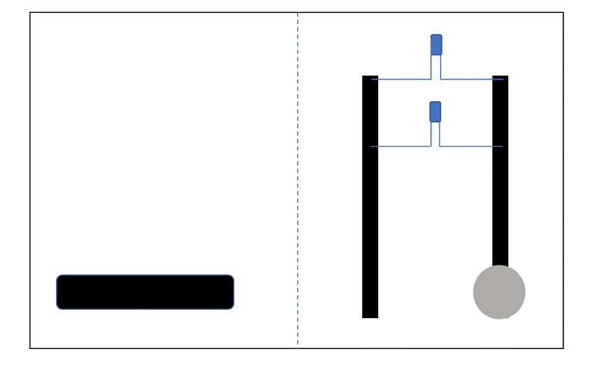

- Put a red LED and a blue LED on the same battery. Which light is brighter? Why do you think one is brighter than another? The two LEDs are made from different materials. One takes more energy than the other to make the LED light. (This is called a band gap in semiconductor physics). Which one do you think takes more energy? If you were a stream of electrons coming from a battery do you think you would go to the light the LED that takes more energy or less?
The blue LED requires more energy so it fades when the two LEDs share one battery.

