Graphing the Spread of Disease Assessment
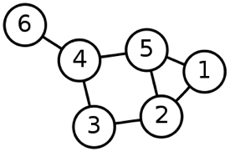
- What is the vertex list for this graph?

- What is the edge list for this graph?

- What is the adjacency matrix for this graph?

- What is the adjacency list for this graph?

- Starting at vertex 1 and using a DFS search, what would be the visitation order of the vertices? Do the same for a BFS search.

