**Graphing the Spread of Disease Assessment Answer Key**

1. 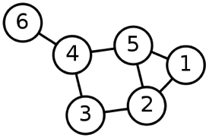**What is the vertex list for this graph?**

**1, 2, 3, 4, 5, 6**

1. **What is the edge list for this graph?**

**(1, 2), (1, 5), (2, 3), (2, 5), (3, 4), (4, 5), (4, 6)**

1. **What is the adjacency matrix for this graph?**

**Adjacency matrix**



1. **What is the adjacency list for this graph?**

**Adjacency list**



1. **Starting at vertex 1 and using a DFS search, what would be the visitation order of the vertices? Do the same for a BFS search.**

**A DFS search has a visitation order of: 1, 2, 3, 4, 5, 6**

**A BFS search has a visitation order of: 1, 2, 5, 3, 4, 6**