Social Networks Activity Instructions
Step 1: Data Collection
Your first goal is to track the interactions between people you know. This activity helps you determine where information can most efficiently be distributed, what kind of role each friend plays in your relationships, and better understanding of your social group. Gather data by either looking closely at a social network you are subscribed to (such as Facebook, twitter or MySpace) or your daily interactions throughout the day.
If looking at Facebook, look at about three pages worth of interactions. For the people that you interact with on those three pages, go to their FB pages and see who they have been interacting with on the first pages of their walls. If you have timeline, do not go back earlier than 30 threads on your wall and 10 threads on others’ walls.
If a person comments on your wall and you respond, give a numerical value of 2 to that interaction. If the conversation continues, count the number of posts in the thread between the two people for the interaction. If someone enters the post later, count the first post and their later post as the interaction. The first post in a thread is the conversation starter. Assume this is targeted only at people who participate in that conversation.
Not all interactions are between just two people. Sometimes you must decide if a person is speaking to one other person or a group. If a person is speaking to a group and only one person responds, only record 1 interaction between the first person and the group and 2 between the first person and the second who responded.
Count “Likes” as interactions. If the number of Likes exceeds 10, only do the first 10.
Example:
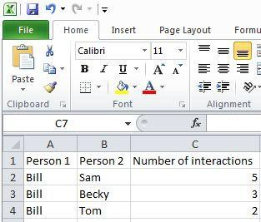
Sam: lol. Last weekend was awesome!
Bill: All we did was play
video games? Sam: and it was awesome!
Likes(10) Becky: Hey Bill did you get the
science homework?
Bill: Yeah but you won’t
get it.
Becky: I’ll just say I
couldn’t get ahold of
anyone.

Likes(0)
Sam: My mom won’t stop texting
me in English!
Bill: Mine either. I lost my phone three times last
week.
Tom: I finally gave up and left my phone in my locker.
Likes (7,000)

Note: Do not repeat interactions. If Bill and Sam are interacting, do not make a new column for them to interact in later, or reverse the order and count again.

Step 2: Data Application
Use the open source program Cytoscape to look closer at the networks you created.
- If your computer does not have the Cytoscape program, obtain it at this website: http://www.cytoscape.org/
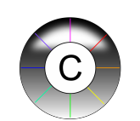
- Click “Download Cytoscape now” and follow the instructions to download it.
- The Cytoscape icon looks like this:

Instructions:
- Open Cytoscape.
- Click File > Import > Network from table (Text/MS Excel).
- Click on the Select File(s) button > select the Excel file you created from where you saved it on the computer.
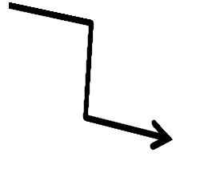
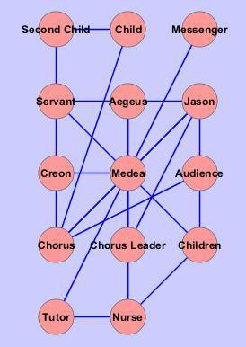
- Select the interaction relationship. Set Source Interaction to the column containing the first person. Set Interaction Type to the column containing the number of interactions between person #1 and person #2. Set Target Interaction to the column containing person #2.
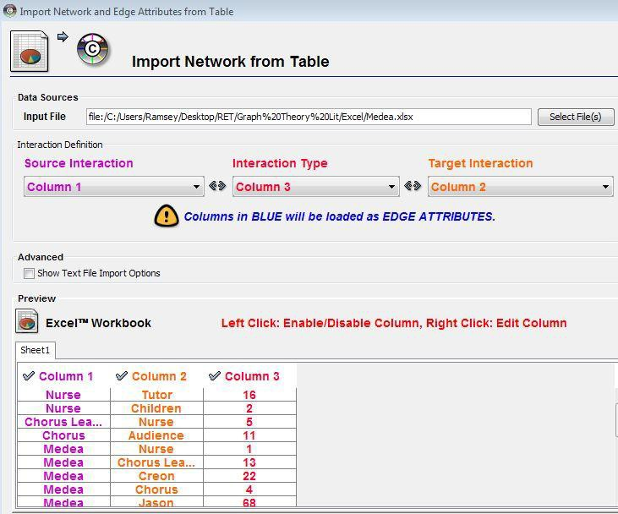
- Click Import and Cytoscape
renders a rough version of
the network that looks like this:

- In order to make the data useful, click on the Plugins menu at the top of the page > select Network Analysis > click on Analyze Network.
- Select the Treat Network as Undirected bubble > click OK.
- Select Visualize Parameters, which alters the nodes and connections.
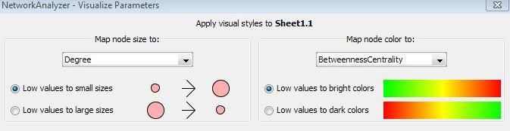
- Set the Map node size to “degree.”
This represents the people that do the most
communicating as larger nodes.
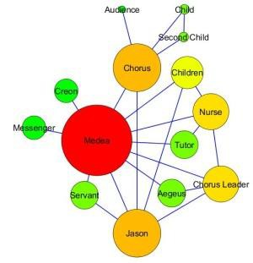
- Set the Map node color to
“BetweennessCentrality.” This changes to
warmer colors the people (nodes) that do the
most communicating with great numbers of other people.
- As necessary, use your mouse to spread nodes out so that they do not block each other.
Now you have a visual representation of your social network relationships showing
which people have the greatest influence with other people.
This same principle can be applied to many other things.

