**Python Calculus Activity Assessment**

**Answer Key**

In your group, have each *individual* member select one of the functions and corresponding input value listed below. For each, create or modify Python code in order to compute the derivative at the given input. As part of the product, explain what you did to analyze the problem, how that analysis led to the changes/modification in the Python code and the results. Then, as a group, collaboratively work problem 5 and answer its sub-questions, a and b.

1.  at 
2.  at 
3.  at 
4.  at 
5. As one group, compute the derivative of  at  and then answer the following:
6. What is different?
7. In terms of the graph of f(x), what is the significance of this difference?

**Answers**

**Problems 1-4:** Students simply need to use the code that was analyzed during the course of the activity (Step 1 and Step 2), change the definition of f(x) to the function provided for each problem, define x as the value provided for each problem and re-run the code.

1. 3
2. -1
3. 0
4. .25

**Problem 5:** No numerical solution exists for #5 because the slopes do not match from the left and right side. This is a demonstration of the derivative not existing at a particular point.

**Solution code for Problem 5:**

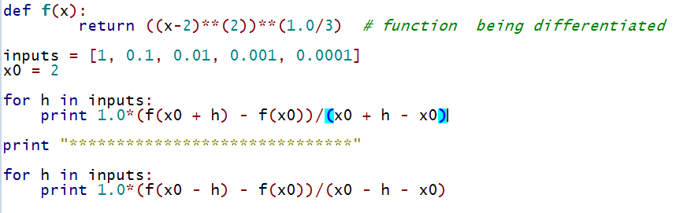

**Results of the solution code for Problem 5:**

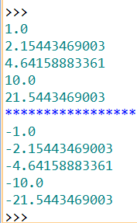

**Answers to the questions for Problem 5:**

1. The derivative values do not converge to a single value. Instead, they diverge, as the values from the negative side are all negative, and those from the positive side are all positive.
2. The graph of  has a non-differentiable cusp at x = 2, meaning the slopes from the left and the right do not agree.

