Python Calculus Activity Handout
Step 1 Python code:
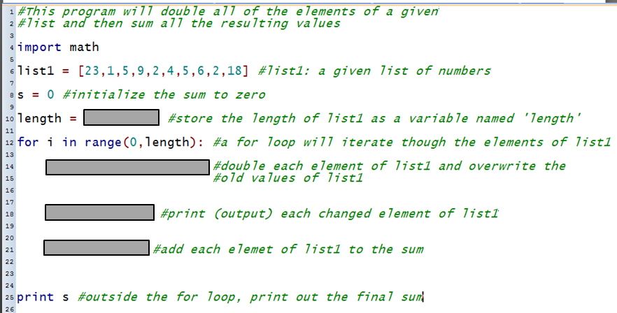

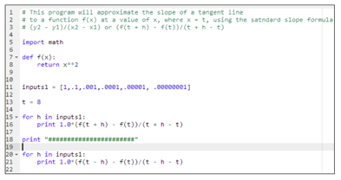
Step 2 Python code:

