Typical Pendulum Setup
Almost infinite ways exist to attach an Android device from a ceiling to serve as a pendulum. Below are two examples of typical pendulum setups when students were given string, tape, cable ties and rubber bands. All methods seem to work well as long as construction is sound and the device is not permitted to slip out of its confines. For ceiling attachment, usually strings were directly tied to exposed girders or to a large binder clip that was clamped to suspended ceiling rails, depending on the ceiling.
Tip: A common issue can be difficulty navigating through the app if students cover the Android device’s controls as part of the pendulum fabrication; careful planning will alleviate this.
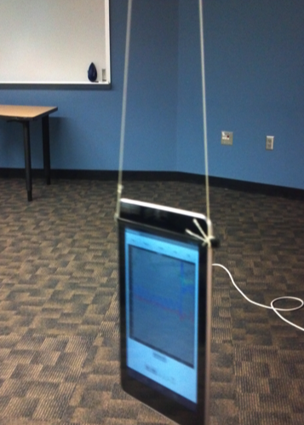

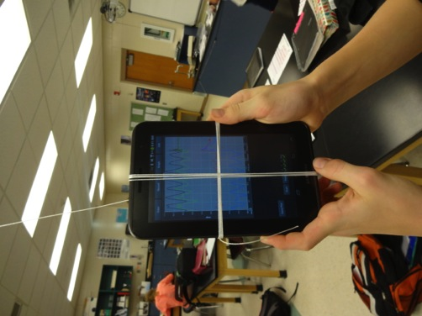

Example 1. Cable ties hold a 7-inch tablet. The ties were tight enough to hold the tablet in place, but could be removed and reattached. Unseen in this photograph, the strings were tied directly to a ceiling girder.
Example 2. Crossing wraps of tied string secure a 7-inch tablet. In this case, the tablet lays parallel to the floor. Unseen in the photograph is a binder clip on the suspended ceiling rail to provide ceiling attachment; see detail below.

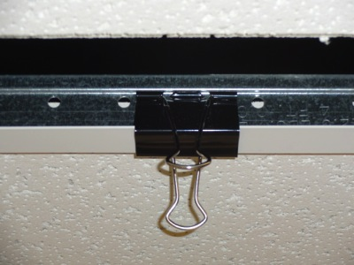

Ceiling binder clip detail. A suitably sized binder clamp makes a secure attachment point for the pendulum.
CAUTION:
Overloading this setup
may cause ceiling damage.

